**Racing cars**

Prof. Khalil Ali Ziq

King Fahd University of Petroleum and Minerals

Department of Physics

Part I:

Hello

I am Dr. Khalil Ali Ziq. I work at King Fahd University of Petroleum and Minerals in the physics department. My research interests are in the development and manufacture of superconducting materials and to study magnetic properties. My research interests related to teaching are in finding new methods to make simple experiments that illustrate physics concepts in a simplified manner.

Our topic for today discusses the basic principles of physics that affect the performance and stability of racing cars. These basic principles are the same that affect an airplane during its flight. These principles also affect the stability of the airplane during its flight.

In an exciting race between a racing car and a jet fighter that recently took place at an airport in the USA, an unexpected and somewhat strange result occurred.

What do you expect? Who will win the race?

Let's see in the next section.

In an exciting race between a racing car and a jet fighter that recently took place at an airport in the USA, an unexpected and somewhat strange result occurred.

What do you expect?

As we have seen in the previous section, at the beginning of the race, the car was faster than the airplane, and was moving ahead of the airplane on the runway. However, we noticed that the plane began to fly, although it is slower than the car, while the car continued on the runway. Why? What do you think was the reason?

Part II: Activity: (4 minutes):

In an attempt to understand the reason why the airplane flies although it is slower than the car, let us first understand the effect of the airflow on the surface of the car and the airplane at the same time. We need to do the following two activities with the following materials:

• 4 paper - A4-

• Plastic tubes (straws), 3 or 4.

1. Fold two papers edges about 1 cm from the top, then fold it around the plastic tube (straw) at the higher end like this. Hold the two tubes, with the papers hanging freely.

2. Put a third tube in between the papers and blow. You will notice the two papers move towards each other. This means that the pressure on the outside of the papers is higher than that on the inside.

Fig. 1

To understand the reason why the papers collapsed, we need to look at Bernoulli’s equation. The equation describes the relationship between the speed of the fluid (air in this case) and its pressure. This equation is a representation of the principle of conservation of energy (potential energy and kinetic energy) as applied to fluid. According to this relation, as the speed of the fluid increase, its pressure decreases. As you blow between the two papers, the velocity of the air increases, consequently the pressure in between the papers drops below the pressure outside. As a result, the papers will be pushed towards each other.

Bernoulli's equation can be written in a simple form:

{v^2 \over 2}+gz+{p\over\rho}=\text{constant}

Where the variables are defined as follows:

ν: is the speed of the fluid.

z: the height

p: the pressure

ρ: the density, and

g acceleration of gravity.

For a fixed height, it can be written as:

ν2 +2p/ρ = constant.

The following activity illustrates how the flow of air on a surface leads to a net lifting force on the surface similar to what happens on the wing of the airplane.

The second activity

We need to A4 paper and plastic tube (or straw). Hold the paper by its sides (both edges) and bend into an arc then blow on top using the straw (see fig.2).

Figure 2

We notice that the paper starts rising as soon as you start blowing on its top. As long as the air above the paper is faster than the air below, there will be net upwards pressure that lifts the paper.

This is what is happening on the wing of the airplane, the air above the wing (the whole body of the airplane) is faster than the air below it. The net pressure is directed upwards lifting of the plane upwards.

Part III (4 minutes):

We found in the previous section how airflow on the surface of the airplane leads to a net pressure (force) that lifts the airplane. But the question now is why air flowing on the surface of the racecar does not cause the car to fly even though it is faster than the airplane at the beginning of the race?

Why doesn’t airflow on the surface of the car lift the car up when it is moving at high speeds?

The pictures shown in Figure 3 represent two cars moving on a straight line. We also imposed the streamlines that represent the line flow above and below the both cars. Airflow on the surface of the car B smother (straighter) than that on car A. Therefore car B experiences less air resistance than car A. It is also well known that straighter streamlines (less bending) indicate higher air speed. This means that the speed of air underneath the vehicle is higher than the speed above. As illustrated in Figure 4, there will be net pressure acting downwards on the car, which translates into a net downwards force on the both cars.

Figure 3.

Figure 4.

The third activity: Making a kite (paper airplane).

We need an A4 paper. Fold it half way through, then from the folded edge fold again in a triangle shape. Fold the triangle in half form midline. Then fold each side of the triangle making both sides look like wings. The last step can be repeated with different wingspans and curvature. Students are advised to try different wing shapes. Try as much as possible make identical (symmetrical) wings.

Note that you can introduce different shapes to the wings by binding them up or down. Students may try several airplanes then throw them in the air to find out which lasts longer in air, flies higher in the air and so on…

How does airflow affect the stability of the plane and the car? And how does it prevent the car from flying, while the opposite happens in the case of the airplane?

Notes:

**First**: use the observations and results of previous activities along with Bernoulli equation.

**Second:** discuss some other applications of the Bernoulli equation.

**Third**: as an additional exercise, attempt to analyze the “simple” streamline of airflow (non-turbulent flow) on the surface of the car as it relates to speed (and the change in velocity) to the slope of the stream lines.

**Fourth:** what is the best shape of the racing cars? Smooth? With sharp angles? With several steps? Where are the maximum and minimum speeds (for airflow)?

Part IV (4 minutes): Newton's third law

We have seen in the previous segment how airflow above and under the car with different speeds leads to a difference in pressure with a net downwards forces acting on the car. This also leads to an increase in the normal (reaction) force acting between the tires and the ground, giving more stability to the car while traveling at high speeds. This is completely different than what happens in the plane, where the final result leads to a net upwards force due to different air speed above and below the wings.

The natural question now is how do these factors affect the frictional force “increase or decrease” between the tiers and the road; and the forward motion of the car?

To answer these questions we will discuss Newton's third law and how the tires interact with the road. We will also comment on the importance of the frictional force in car racing.

Let's ask the following simple obvious question: when we walk what are the forces that affect us? Do I push myself when I walk? Or is there another force that affects me when I walk? The question again: What is the force that affects us when we walk?

When we start walking, we push the ground (road) by one foot backwards by a force (F) - Call it the power to action. The ground pushes back with a forward reaction force (R). According to Newton's third law the force of the reaction is equal in magnitude and act in the opposite direction of the action force. It is this reaction that pushes us and moves us forwards.

**But let us consider the following questions:**

- What if the ground is slippery - for example, during the rain?

Or we try to walk on ice?

C:\Documents and Settings\Administrator\Local Settings\Temporary Internet Files\Content.IE5\M4IWIEXZ\MC900198472[1].wmf

C:\Documents and Settings\Administrator\Local Settings\Temporary Internet Files\Content.IE5\AJG45R59\MC900141253[1].wmfActivity

- Discuss the forces of action and reaction when we walk quickly (running for example).

- How does friction affects walking?

- When you are exercising on a treadmill; what are the forces involved? In what direction does the belt on the treadmill moves? What is the force that is acting on you and in what direction?

When we are walking on the belt of the treadmill, we push the belt backwards, and as long as it is free to move it will move in the same direction as the force acting on it, backwards. At the same time, the belt reacts by a reaction force on us. All right, but why do we not move?

Let us now return to the racecar, or any other car, as a matter of fact. What is happening between the tires and the road or the street? What are the forces involved, for example?

When the tires of the car spin, they push (action force) the road backwards; the road reacts by a reaction force that is directed in the forward direction. This in turn is what moves the car forward.

The force of the reaction depends on the coefficient of friction (μ) between the road and the tires of the car. Moreover, the maximum force of friction (fr) acting between the tires and the road depends on the normal force (N) –the reaction force between the ground and the car- and is given by the following relation:

fr = μ N

It is worth noting that the normal force (N) represents the ”total” reaction force from the ground to car. This force equals the sum of weight of the car plus the force resulting from the difference in the speed of the air above and below the car as we found through the Bernoulli equation. Both forces are directed downwards. This means that the faster the racecar, the greater the “downward” vertical force, which in turn increase the normal force and hence increasing the maximum friction force. This in turn leads to:

- Increase in the reaction force, thus increasing the acceleration of the car.

- Increase in the stability of the car.

Let us try to answer the following questions:

- What happens if the ground is slippery, for example? Like when it is raining, for example, or if we try to walk on icy road?

- What happens when the car accelerates?

- Why are the tires of a racecar wide and smooth and do not contain grooves as normal tires?

- Why are the tires of the racecar soft and sticky? How is that related to the force of friction and/or to the coefficient of friction?

Part V

Before starting the race, the drivers of the racing cars tend to spin the wheels of the car very quickly without moving the car in order to raise the temperature of the tires. In doing so, the rubber becomes softer and that increases coefficient of friction with the road. This will also increase the maximum value of the friction force between the tires of the car and the road.

The wide tires of the racing car provide a wide contact area with the road and better grip that helps with the stability of the car. The softer tires tend to stick to the road and have higher coefficient of friction; this leads to increase the maximum force of friction between the car and the road.

It is noted that racecars have low ground clearance, is that important? Where is the center of mass of the car in this case?

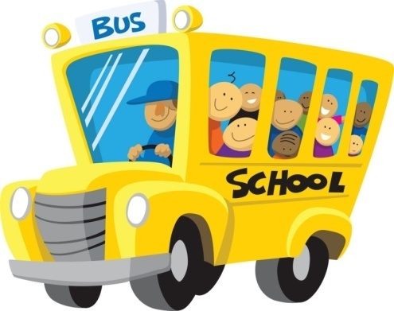C:\Program Files\Microsoft Office\MEDIA\CAGCAT10\j0216858.wmf

Figure 1:

Which car shown in figure 1 can turn on a bend road with greater safety, especially at high speeds?

Which car is more stable, especially when side wind is blowing?

To compare the stability of a racecar with bigger vehicle, a Bus for example, we need to do the following fourth activity.

What we need:

1. A piece of cardboard.

2. A piece of wood approximate dimensions of (5X10X20 cm3).

3. Protractor to measure the angle.

Figure 3

Figure 3

Begin by placing the piece of wood as in figure 2, and then gradually start lifting the cardboard and stop when the wood starts sliding or tip over, then measure the angle.

In the following activity we placed the piece of wood as shown in figure 3, and then gradually start lifting cardboard and stopped when the wood started sliding or tipped over. We then measure the angle.

In both cases compare the angle at which the piece of wood tips over or starts sliding. Which arrangement gives more stability? Compare that with the Bus and the racecar.

Last Activity:

Note that the piece of wood has different dimensions such that we can get two more stable arrangements. Students are required to try different possibilities by placing the piece of wood on the cardboard and measuring the angle at which a piece of wood tips over or starts sliding. Make a record of all readings. What do you conclude?

Let us return now to the car and bus. Because the bus is higher than the car, its center of mass is located at higher position than that of the racecar. This means the bus is less stable when it makes a turn. The racecar is more stable than the bus as its center of mass is at much lower position. For this reason, designers of the racing cars try hard to lower center of mass of the car as much as possible, so that it is close to the earth's surface.

Part VI

In this section we will obtain an expression for the maximum safe speed (v) of the car moving on a horizontal circular path (Fig. 4). If the vehicle speed exceeds the speed limit then the car starts to slide out.

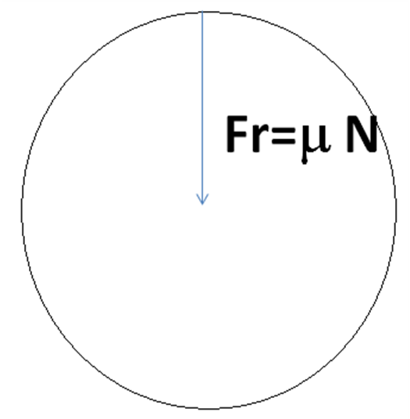

The central force =maximum frictional force. We have:

**Fc=mv2/R =N**

**Then v= √(R *  g)**

Figure4

The coefficient of friction on rainy days decreases according the amount of the water covering the road and the variations of the viscosity at the road. This will greatly affect the maximum speed of the car at turning at a curve, leading to a wide range in the maximum safe turning speed. In practice we cannot post a wide range of maximum turning speed at the side of the road. The question now: can we design a curved path (or road exit) such that the maximum safe turning speed does not depend on the coefficient of friction?

Let's think about this question and try to find the answer.

Before we answer this question let us remember that the wheels of a racecar do not contain grooves. This means that when the track is wet (during rain for example), the water makes a thin film between the wheels and the road, leading to significant reduction in the coefficient of friction, thus decreasing the maximum safe turning speed limit.

Now think: How to design a curved path so that the maximum speed does not depend on the coefficient of friction.

The solution was simple and effective. The road engineers designed a circular path that is inclined at an angle (~20 degrees) from the horizon.

Let the radius of the track equals R, and the normal reaction force to the weight of the car is N, as shown in the figure below. We can write the following relations:

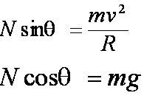



Where v is the maximum turning speed of the car, which does not depend on the coefficient of friction as before.

**The effect of friction force:**

It is worth noting that if cars exceed this speed, they will slide towards the outside, then the force of friction begins to affect their motion. The friction force has an additional component (µN cos θ ) directed towards the center of curvature of the turn. We have:



Substituting the value of N using the following relations, and balancing the forces in the y direction we obtain:

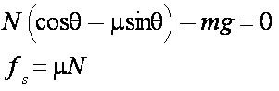Hence:



This speed is clearly larger than the corresponding value for the speed that we obtained in the case of the horizontal track



Note from the previous equations that the maximum speed of the car on the turn depends on:

1. The coefficient of friction

2. The radius of the curve

As can be seen, the speed does not depend on the mass of the car. This means that the maximum speed of the car at the turn is the same for all cars regardless of their mass.

Activity: Make sure that all students do example calculations of the maximum speed for all previous cases.

Part VII (three minutes):

In this video we have learned how to use some simple physical principles to help us understand how an airplane flies and how we can apply the same principles to racing cars. We also learned how to increase the stability of racecars and to understand some of the design aspects related to the exterior shape of the race cars. We also discussed the Bernoulli principle and Newton's third law.

Before we leave, we should emphasize the need for safe behaviors when driving and to obey driving laws.