**APPROXIMATING THE VOLUME OF SAND DUNE**

**Dr. Mohammad Z. Abu-Sbeih**

**Department of Mathematics and Statistics,**

**KFUPM, KSA**

In the name of God, the most merciful

Peace, mercy and blessings of God be upon you,

I'm Dr. Mohammed Zuhair Abu sbeih from King Fahd University of Petroleum and Minerals

I would like to welcome you to this lesson of BLOSSOMS, and I hope that you’re feeling good today and are full of energy.

Today we have an interesting and challenging question, and will support the skills that you have learned in school. Today’s question will be on one of the fundamental problems facing Saudi Arabia and many countries in the region and the world at large, namely, sand movement. This movement of the sand threatens vital projects and houses in the region such as airports, railways, factories and residential areas and roads. There are a lot of ways and projects to control the movement of sand. Let's highlight this issue and its dimensions through this video, which depicts sand movement near vital installations.

Video photographer (explain the following during the presentation)

*The origin of sand dune formation is the wind movement, which carries sand particles. Shrubs, rocks or fence posts can obstruct the wind force causing sand to pile up in drifts and ultimately in large dunes.*

**Activity 1:** List three key factors that affect the movement of sand. See you shortly.

**Part II:**

Welcome dear students and I expect you have mentioned the following reasons: wind speed, size and weight of sand particles and humidity.

There are many types of dunes and they vary depending on the wind blowing on the dunes. The most important types of dunes are:

The Barchan Sand Dune (Crescentic dunes)

Linear sand Dunes (Longitudinal or Seif dunes)

Dome Dune

Star Dune

Oval Sand Dunes (Elliptical dunes)

The different forms of dunes depend on the dimensions, sizes, appearance, slipfaces and general pattern. The most common form of sand dunes is the barchan or crescentic dunes. This type of sand dune, which resembles a crescent, has a slipface on the concave side of the dune in the direction of wind, and is usually caused by mono directional wind and is the fastest moving dunes.

The side facing the wind is called windward while the slip face has two arms on the sides with less height than the dune pointing to the wind direction. Changing the wind direction usually causes a change in the shape of the barchan dune to other forms such as dome and elliptical dunes, and may result in complex dunes. We note also that in the mono directional wind the dune movement looks as if the dune is one unit in the direction of the wind.

[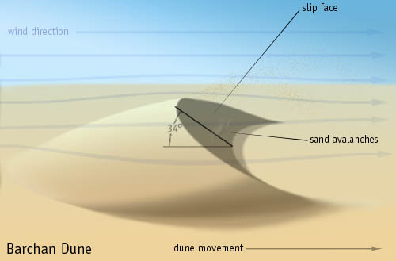](http://upload.wikimedia.org/wikipedia/commons/3/33/Barchan.jp)

This is a photo from the [Wikimedia Commons](http://commons.wikimedia.org/wiki/Main_Page). Commons is a freely licensed media file repository

**Activity 2:**Name three major factors to control the movement of sand towards vital areas.

See you shortly.

**Part III:**

Welcome back and I hope that you got suitable answers for sand dune fixation such as: cultivation, spraying oil over the dunes, as well as manmade barriers.

In this lesson, we will focus on one type of dunes, the barchan or crescentic dunes which are the most famous and common dunes in the area.

Assuming that there is a sand dune moving towards a vital installation and we want to remove it, how can we calculate the volume of a dune? From repeated observations of this type of dune note that the side facing the direction of the wind, which is known as windward, makes the angle with the base, while the slip face makes an angle of  with the base as shown in Figure

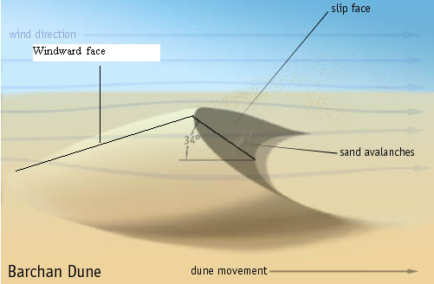

Making a sketch in three dimensions, we see that there are three parabolas you can see in the following sketch

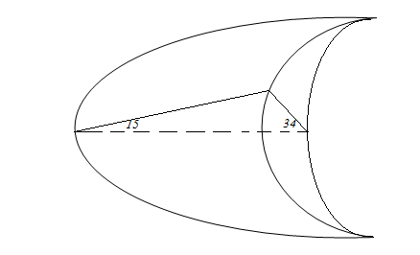

Figure 3

**Activity 3**: what dimensions (parameters) do you need to calculate the size of the sand dune? See you shortly.

**Part IV:**

Welcome again and I hope that you have got a good answer to the previous question.

As shown in the following figure-4, we may need to know:

* The width (the distance between the tips of the two horns) and let us assume it is 2*a*.
* The distance of from the vertex of the first parabola to the line joining the horns. Let us call this distance *b*
* The distance between the vertices of the two parabolas in the base and let us call this distance *c.*

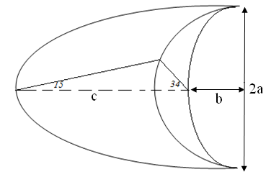

Figure 4

**Activity 4**: How can we approximate the volume of a dune? Can you suggest a method to do that? Think of a method and discussed your answer with your colleagues in the group. See you shortly.

**Part V:**

Welcome again and I hope that you have proposed a convenient way to calculate or approximate the size of the dune. We shall use the slice method to find the volume as we shall do to this model.

We may summarize the procedure as follows: cut the body into parallel slices with small thickness so that the volume of each slice is calculated by multiplying the area of the slice by the thickness. When we add the volumes of these slices, we get a rough approximation of the volume. By reducing the thickness of slices we get a better approximate of the volume.



**Rule:** suppose a body lies two planes perpendicular to the *x*-axis, such as and. If the area of the cross section at *x* in the interval [*a*,*b*] is represented by the function which is continuous at each *x*, then the volume *V* of the solid is given by:



(V equals to the integral from a to b of A (x) multiplied by dx.)

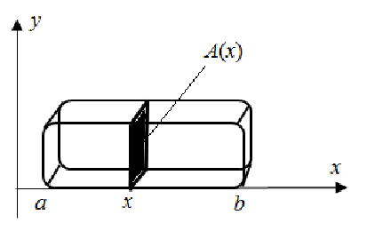

Figure 5

Now we will use this rule to calculate an approximate value of the volume of the sand dune. Let us return to the graphic illustrations and try to project it down to the plane as follows:

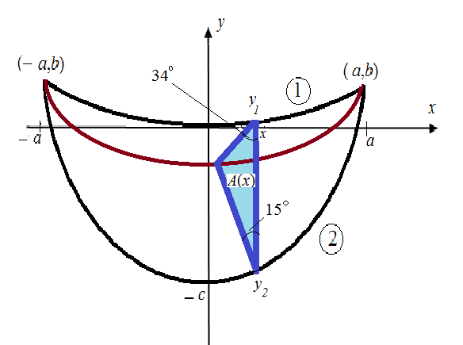

Figure 6

Let us assume that at every point *x* inside the interval [*a*,*b*], the cross section  perpendicular to *x*-axis is a triangle with base  and the neighboring angles to the base are  and as shown in figure above. To calculate the area of the cross section we need to:

1. find the equation of the first parabola (1)
2. find the equation of the second parabola (2)
3. the height of the blue triangle in figure.

**Activity 5**: Try with your colleagues in the group to find the equations of the parabolas (1) and (2) in the following graph. See you shortly.

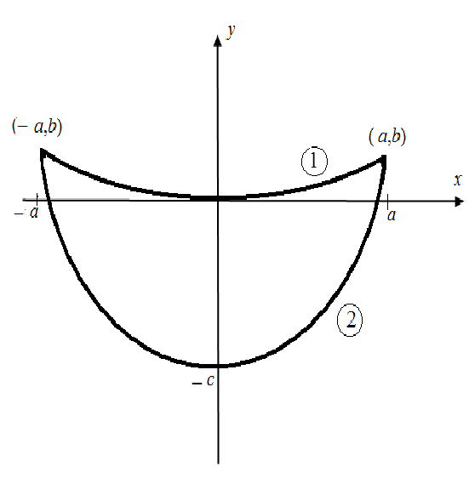

Figure 7

**Part VI:**

Welcome again, dear students, now let us see what you got!

First, we calculate the first equation: The general equation of a parabola is and since it passes through the points andwe substitute in the equation to get three equations:

, ,

Solving for *A*, *B* and *C*, we get , and . Thus the equation of the first parabola is:



Second we calculate the equation of the second parabola. In the same way we substitute the points and  in the equation to get the equation of the second parabola:



**Activity 6**: Try with your colleagues in the group to find the height *h* of the triangle (cross section) as shown in the following figure in terms of the base D.

See you shortly.

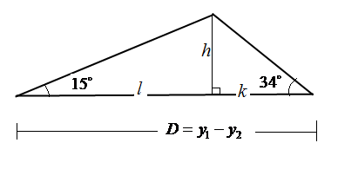

Figure 8

**Part VII:**

Hi again and let us see how to get the height of the triangle, and I hope that you have to find sees rise in triangle, and see how we get:

From the triangle on the right we have: 

And from the triangle on the left we have: 

Equating the two values of *h* we get:



Hence we conclude that the base of the big triangle is equal to:



That is****

And since 

We get



were is the base of the triangle.

**Activity 7**: Try with your colleagues in the group find the area of the cross section (triangle) perpendicular to the *x*-axis at point *x*. See you shortly.

**Part VIII:**

Hello again everyone, I hope that you were able to find the area of the cross section (triangle) perpendicular to the *x*-axis at point *x*. Note that the area of the cross section (triangle) perpendicular to the x-axis at point *x*. is equal to:



This is the area of the triangle or the vertical cross section on the x-axis, and now we want to apply the previous rule using the area of the cross section.

**Activity 8**: try with your colleagues in a group to set up a definite integral and calculate the volume of the sand dune. See to you shortly.

**Part IX**: Welcome back and let us see the how to calculate the volume by using the previous rule:



As you can see we may approximate the volume of the dune by using the formula  were *a* is half the distance between the horns and *c* represents the vertical distance between the vertices of the two parabolas surrounding the dune on the ground.

This concludes today’s lesson and I hope that you got in this lesson new information and an application to one branches of mathematics, which will prompt you for further study and research in the phenomena of this universe to overcome the natural problems. Peace, mercy and blessings of God be upon you.