Handout 3
Activity 7: Calculation of Value of SP (Subject Property)
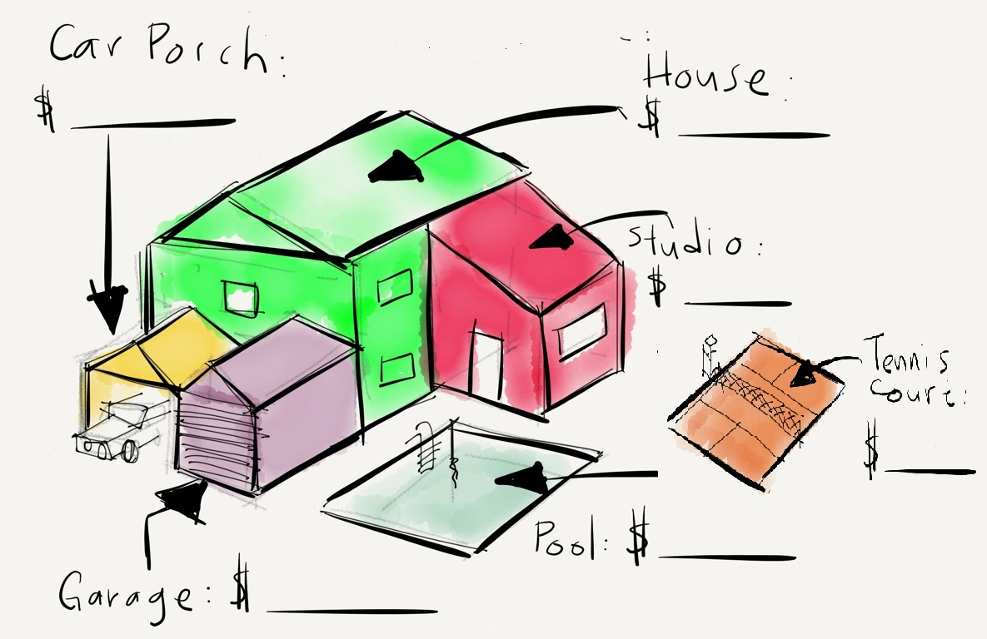
CAR PORCH
$___________________

$ _______________
HOUSE
$___________________

$ _______________
GARAGE
$ ___________________

$ _______________
POOL
$___________________

$ _______________

Given the figure as such, what is the value of subject property (SP) which includes a house, carporch, pool and garage?
CAR PORCH

$ _______________
HOUSE

$ _______________
GARAGE

$ _______________
POOL

$ _______________
CAR PORCH

$ _______________
HOUSE

$ _______________
GARAGE

$ _______________
POOL

$ _______________

