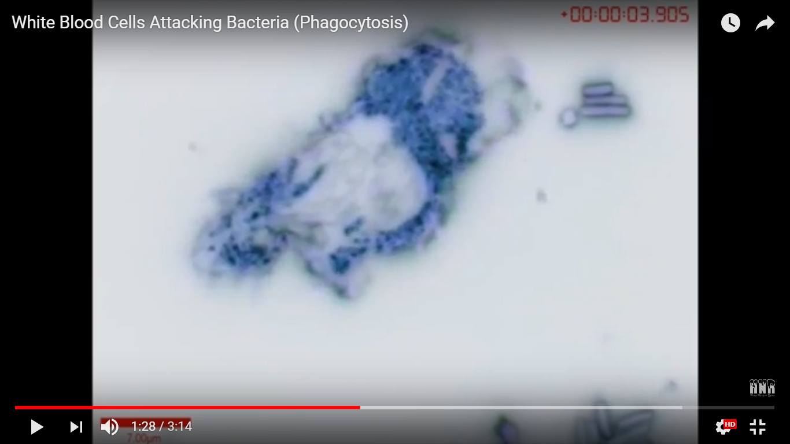

Bacillus-shaped bacterial cell

Animal cell

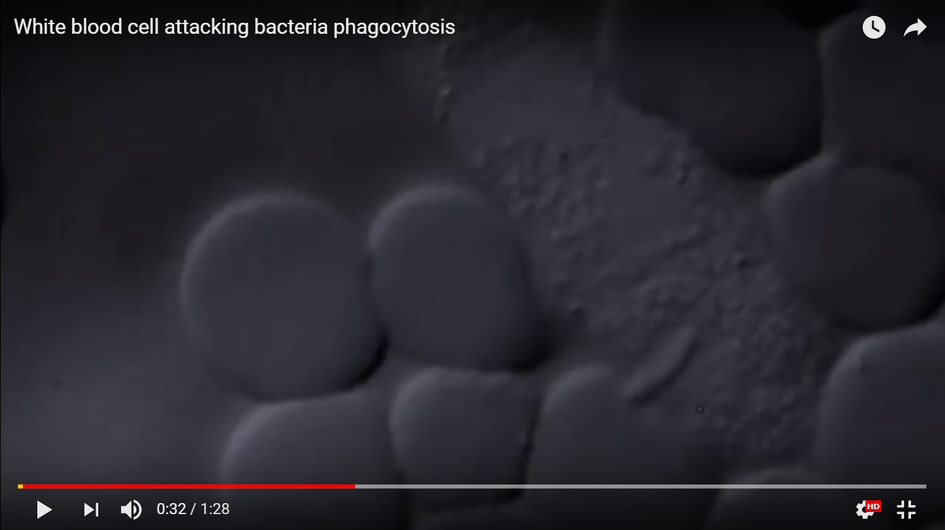

Four animal cells

Bacillus-shaped bacterial cell