Kite Flying Formula
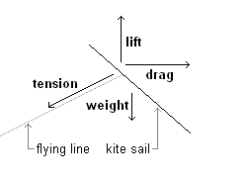
Formula for some of the forces will be introduced as well as explanations on concepts such as Newton’s Law of motion, Bernoulli’s principles, and aerodynamics forces.
The formulas that will be shown are as follows:
The lift L is equal to a lift coefficient C_{l} times the projected surface area A times the air density ρ times one half the square of the wind velocity V
$$L=C_{1}Aρ\frac{V^{2}}{2}$$
The drag D is equal to a drag coefficient C_{d} times the projected surface area A times the air density ρ times one half the square of the wind velocity V.
$$D=C_{d}Aρ\frac{V^{2}}{2}$$
Forces involved in Kite Flying
(a) Gravity and lift; Bernoulli’s principles
When something is in the air, gravity pulls it back down to the ground. When you throw a ball in the air, it comes back down because of gravity. When you put a kite in the air, gravity wants to bring it down. So what keeps it up? The wind keeps it up. Wind creates lift thus, keeps kite in the air. Generally lift is what happens when wind pushes against something and carries it up. For example a plastic bag gets caught in the wind; lift is what causes it to rise into the air.
Relating to experiment 3.1, when you put a Cardboard A in front of a fan, lift causes it to wave.
So, the force that stops a kite from falling down is called lift. Lift is the force pushing the kite away from the surface of the earth if the wind is horizontal (as in the figure). More generally, lift is the force acting perpendicular to the wind if the kite is fixed. Lift can have a component that is horizontal if the wind has a vertical component, such as when the wind blows over a hill, called drag.
(Referring to experiment 3.2)
An object’s lift also depends on the size of the object's surface, or its area. A piece of paper will float in the wind, but if you crumple that paper into a ball, it won’t float as well because the surface has become smaller. Thus when a kite is lifted by the wind, the wind pushes against the whole surface of the kite to lift it up. When you go outside and you see leaves blowing on trees or flags waving sideways, it’s probably a good kite-flying weather.
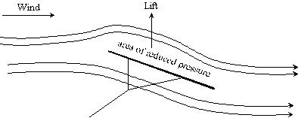
(b) Thrust
Kites remain horizontally in air because of thrust. Birds use muscle power to develop thrust, and aeroplanes use motors.
The thrust that acts on a kite is produced when it (the kite) is being held in one place by its string while the wind flows around the kite. The thrust then overcomes drag. Since the string is held at an angle, it seems that the string also pulls downward counteracting excess lift. If you relax the grip on the string, the kite will ascend higher if the wind is fast enough.
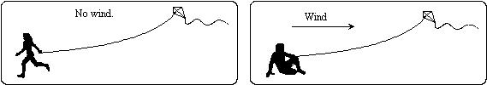
(c) Drag
What stops a kite from flying straight over your head and into the ground on the other side?
Stability and Drag that contributes stability – air friction over the kite’s surface and sticks.
An additional drag is usually created by the tail of the kite, and allows us to make the kite point in the correct direction.

