Teacher Guide
Introduction:
- Main Idea Question: “Do you think all the cancer cells in a tumor have the same mutations?”.
- Pre-cancerous cells acquire certain mutations that allow them to start growing more—these mutations result in more oncogene activity or less tumor suppressor activity
- The pre-cancerous cells continue acquiring mutations as such:
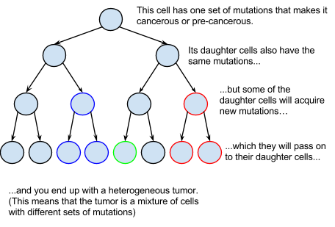
- As cells start dividing faster (such as growing in a tumor), they get worse at making sure that everything is happening right--that none of their DNA is broken and that they have the right number of chromosomes. This means that they acquire more mutations as they go on.

Teacher Preparation for the Activity
- Obtain beads in five colors (plastic play necklace beads in pink, orange, yellow, purple and green are what we use). You’ll need about 30 beads of each color per group.
- Print out one Student Handout per group, and write two colors (which will be the resistance colors for that group) at the top of each sheet. If you have enough students, have several groups with the same resistance colors. Be sure to designate at least one group as ‘No Resistance’.
- Obtain paper lunch bags and plastic cups (6 cups per group).

The Activity

- Students separate into groups of 3. One group of 2, if necessary, works well with the activity and should be designated No Resistance.
- Each 3-person student group has a bag with different colored beads. Each bead is a cancer cell, and the colors represent the different sets of mutations that each of the cells have.
- Ask the students to set up:
  - 10 beads of each color in the bag. (This is the tumor)
  - 5 cups with the sets of beads defined below (Each cup is the number of new cells of each color that are formed by cell division in one unit of time)
  - This usually takes about 5 minutes.
Color | Number
Pink | 1 bead
Orange | 1 bead
Yellow | 2 beads
Purple | 2 beads
Green | 3 beads
- Each group will have one person representing chemotherapy, one person representing growth and one person representing chemotherapy resistance. Students have 1 minute to select their role. For a 3-person No-Resistance group, instead of being Resistance, the 3rd student can act as the timekeeper for the entire class.
- Chemotherapy people will take beads out of the bag one-by-one without looking at the beads in the bag and place them in a dead pile.
- Growth people will “grow” the tumor by adding one of each of the cups of counted beads every 30 seconds.
- Resistance people will watch the dead pile. Every time 3 of either of their resistance colors appear, they will put two of those cells back into the tumor. To be clear, if there are two of one resistance color and one of another, this does NOT count. There must be three of either color. You wrote the resistance colors on the top of their instruction sheet before the lesson.
- The Timer person will call out 30-second intervals for 3 minutes, for a total of 5 growth cycles; at 3 minutes the activity stops and no beads are added.

Analysis
- Students will count the number of cells of each color in the tumor (bag), and then calculate the total number of cells. This will be placed on a chart on a whiteboard/chalkboard as such:
Group | No Resistance | G/P Resistance | Y/Pi Resistance | O/Y Resistance
# Pink Cells | 1 | 2 | 2 | 4
# Orange Cells | 6 | 7 | 6 | 5
# Yellow Cells | 4 | 5 | 6 | 3
# Purple Cells | 3 | 4 | 5 | 6
# Green Cells | 3 | 4 | 5 | 2
Total # Cells | 17 | 22 | 24 | 20
where G/P resistance means the group with green/purple resistant cells, Y/Pi means the group with yellow and pink resistance cells, and so on. If there are multiple groups with the resistance colors, make sure to denote them as G/P 1, G/P 2, ect…
- Using the Excel sheet provided, make graphs representing the data. Have students discuss results vs. expectations and factors that could have influenced the different outcomes.
  - Factors
    - Rate of growth of each color (Green, for instance, grows much faster than pink because each growth cycle adds 3 greens but only 1 pink.)
    - Resistance colors – Green resistance tumors are generally bigger than pink resistance, for the above reason.
    - Speed at which students pull the cells out of the bag
- Statistics Option: students can take average and standard deviation of replicate groups to determine if there was a significant difference in growth rates based on which cells were resistant and compared to the non-resistant group.
  - For advanced students, they can figure out how many replicates and trials they’d have to run to determine if the differences are truly statistically significant and what tests to use to make that determination. (such as a student’s t-test.)
Talking points
- Explain that different mutations in a tumor cell can make the cell grow faster or slower, and be more or less sensitive to chemotherapy
- This means that different cells in a tumor will respond to chemotherapy differently and it can be difficult to predict how a tumor will respond because there are so many different mutations and we can’t even really measure the heterogeneity anyway.
- We’re going to do an activity to try and get a bit of a better understanding of how heterogeneous tumors respond to chemotherapy.
- The bag with beads are tumors/cells and the counted out beads in cups being how the tumor will grow - colors with more beads in each cup grow faster and vice versa.

