Note: It is highly recommended to download BLOSSOMS videos rather than streaming.

The steps below allow you to easily follow steps to either download (or stream if needed) your BLOSSOMS video through Chrome/Safari/Firefox.

Google Chrome
To download with Google Chrome:
- Choose your BLOSSOMS video which opens to the video page.
- In the center of the page, click “Download Videos” and choose “English - MPG 4 (mp4)”
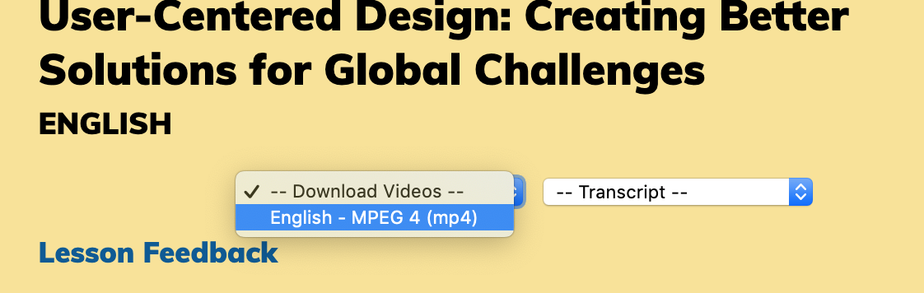

- On the lower-right hand corner, click on the 3 dots and choose “Download”:
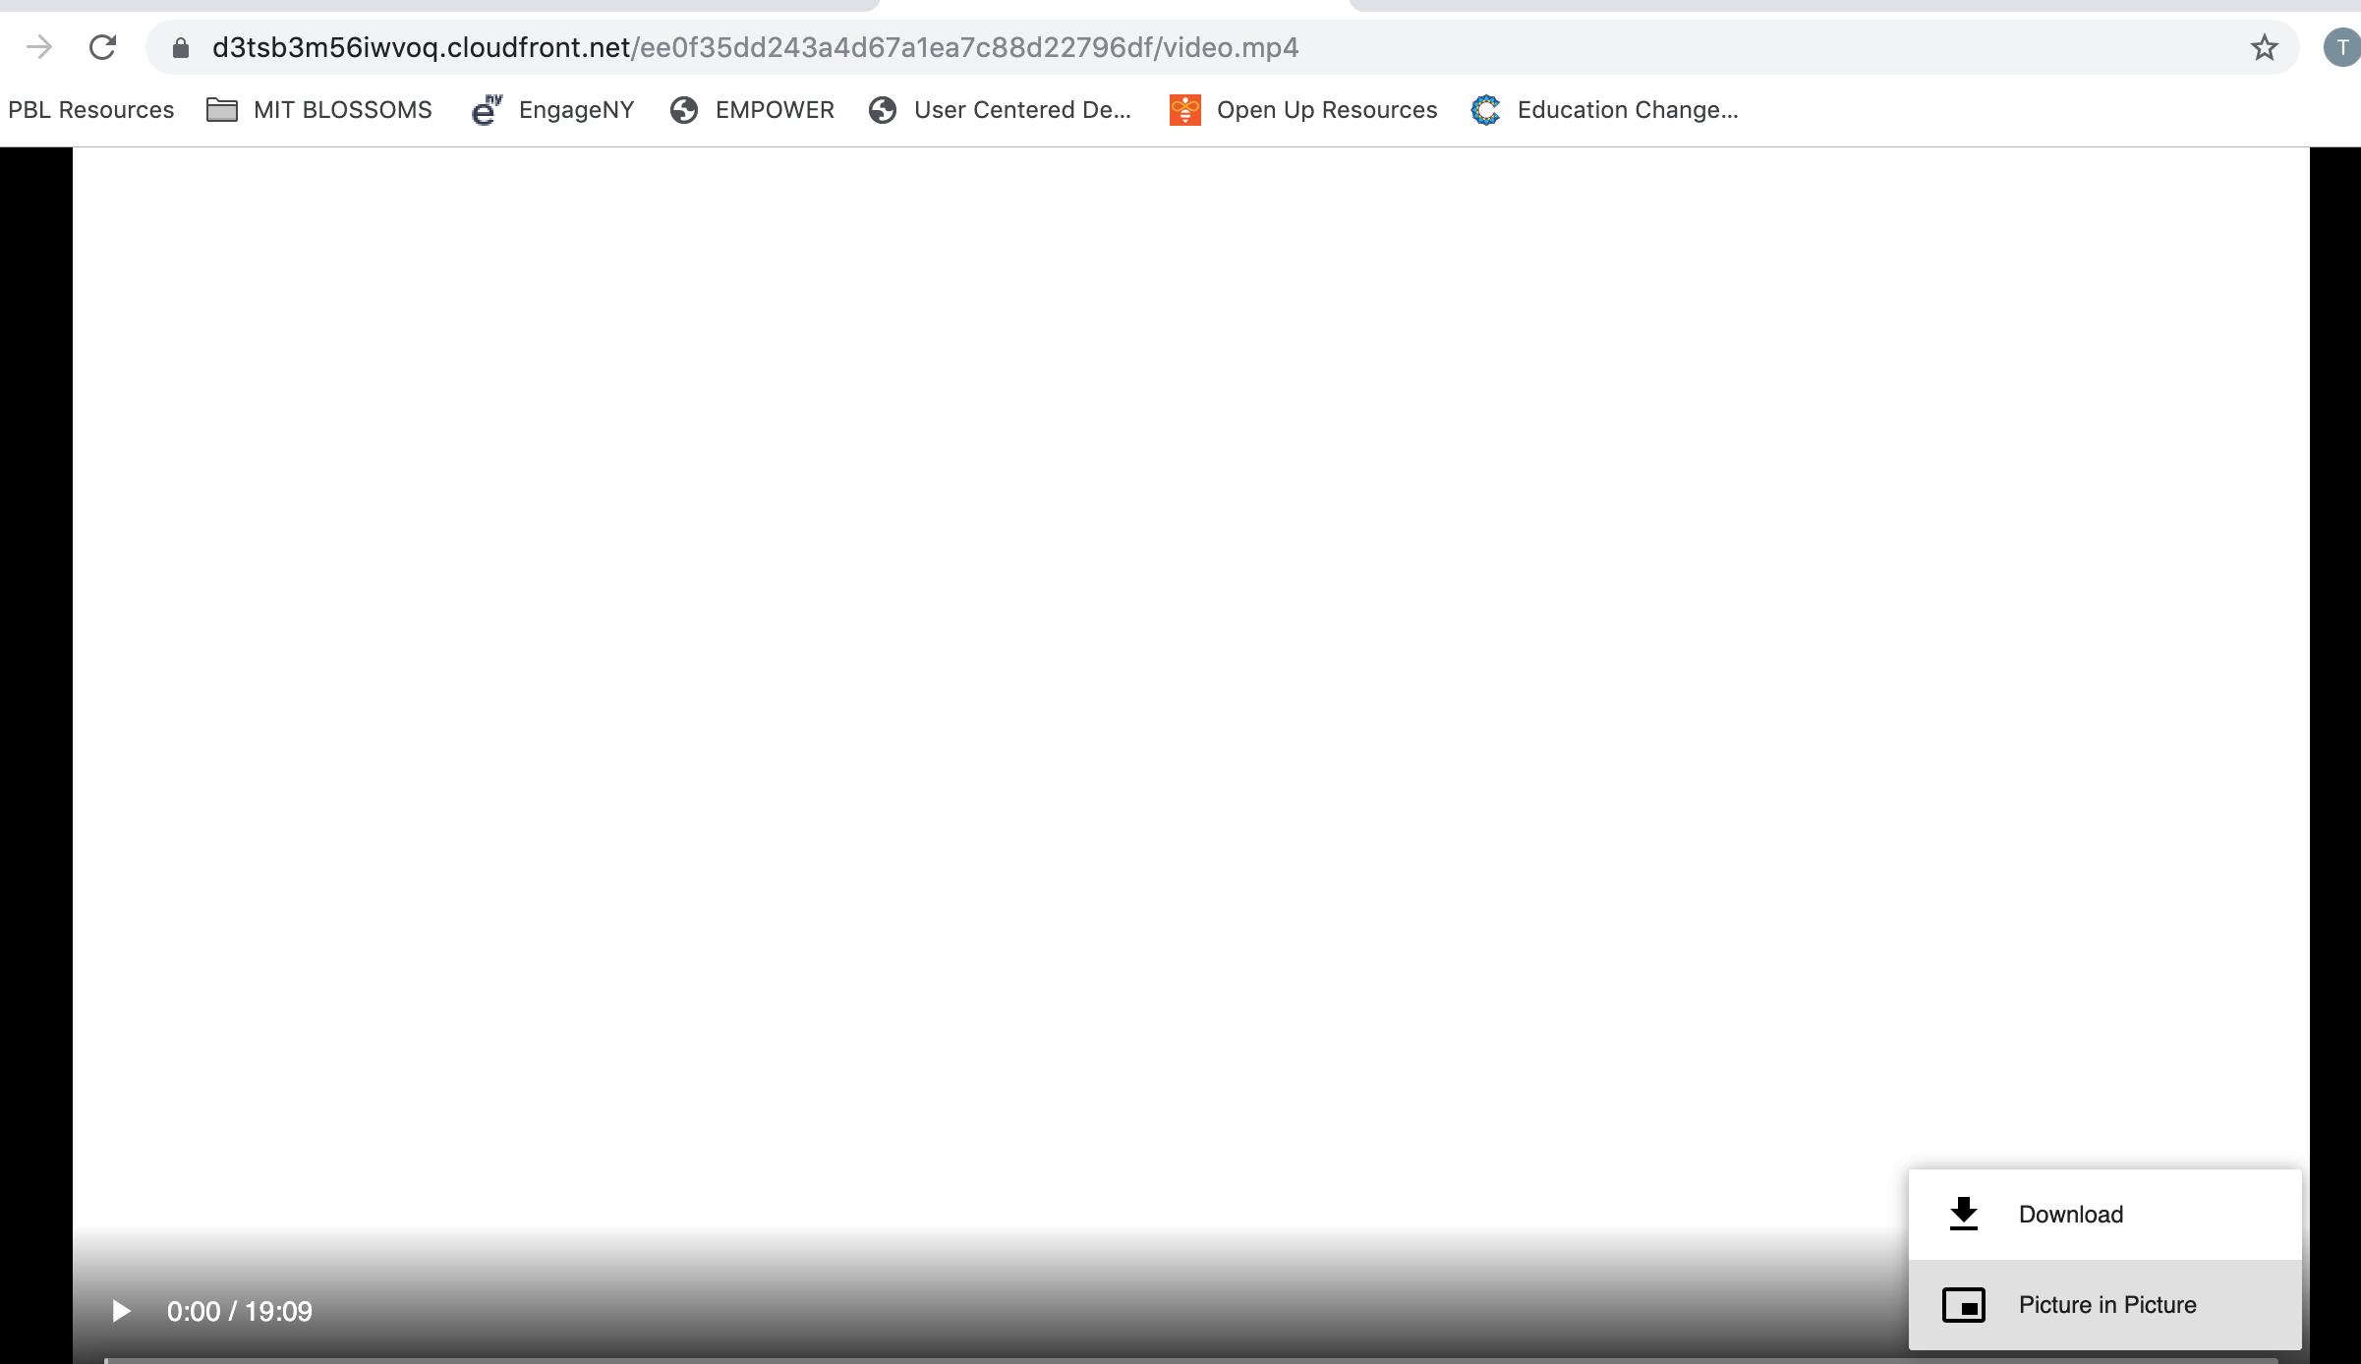

To stream with Google Chrome:
- Open your BLOSSOMS video
- Click on “Download Videos” and choose “English - MPG 4 (mp4)”
- This now opens a new web browser below. Click the play button. In this example, we chose to stream the User-Centered Design lesson.
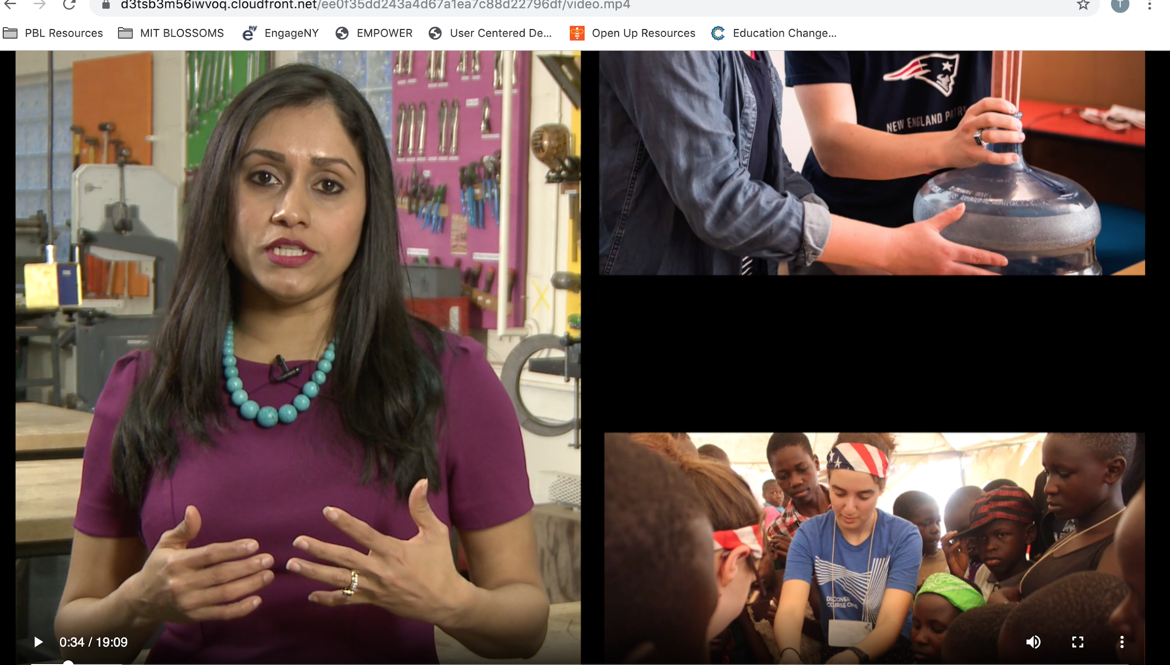

Safari
To download with Safari:
- Choose your BLOSSOMS video which opens to the video page.
- Click on the Download Videos link and choose English - MPEG 4 (mp4)

To stream with Safari:
- Choose your BLOSSOMS video which opens to the video page.
- Click on the play button and the video begins.
For example the User-Centered Design video plays:
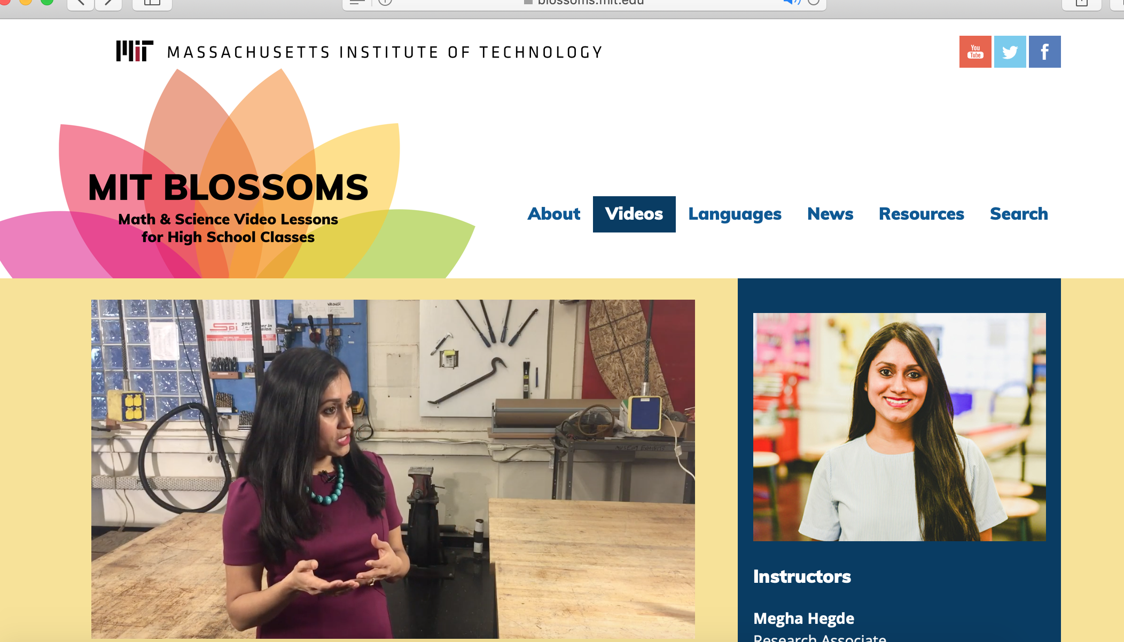

Firefox:
Note: Currently only able to stream with Firefox.
To stream with Firefox:
- Choose your BLOSSOMS video which opens to the video page.
- Click on the Download Videos link and choose English - MPEG 4 (mp4).
The video begins. Here we chose the User-Centered Design video:
