Demonstration: Dissolved Gases in Water Lab
In order for aquatic life to survive it must be able to easily take in Oxygen molecules (O₂) from the water. In addition, photosynthetic aquatic organisms must be able to get CO₂ from the surrounding water.

We are familiar with water being able to dissolve common materials like salt and sugar, but water is good at dissolving gas molecules as well. The concept of dissoved gases in water is often difficult to grasp because unlike dissolving solid materials that become invisible as they dissolve, gases are already invisible and we can’t see them dissolve. So how can we know if they’re present in water? Undissolve them.

Since they already possess a great deal of kinetic energy, gas molecules have a difficult time staying in solution, thus colder water is able to hold more dissolved gas than warmer water. Heating water releases its dissolved gases, demonstrating water’s ability to put gas molecules in solution.

In this simple experiment we will conduct a test to see if there are dissolved gases in a sample of water by “undissolving” any gases in solution.

Materials: Glass test tube, cold water, ceramic mug, a way to heat water.

Procedure: Evidence for dissolved gases in water.

First: Fill a ceramic mug about 2/3 to 3/4 full with hot water. (Any container that can hold hot water can be used for this).

Next: Fill a glass test tube with cold water from a tap or other source and note its appearance.

Then: Place the test tube with cold water into the hot water bath for about a minute or two then take it out and note its appearance. It should have a lot of tiny bubbles attached to the inner wall of the
test tube.. the dissolved gases have become “undissolved.” Remember if you can see it , it’s not dissolved.
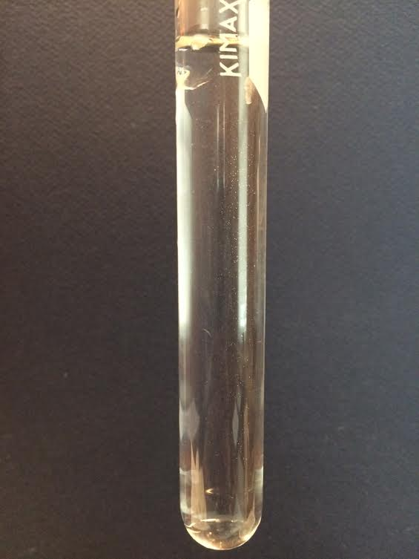
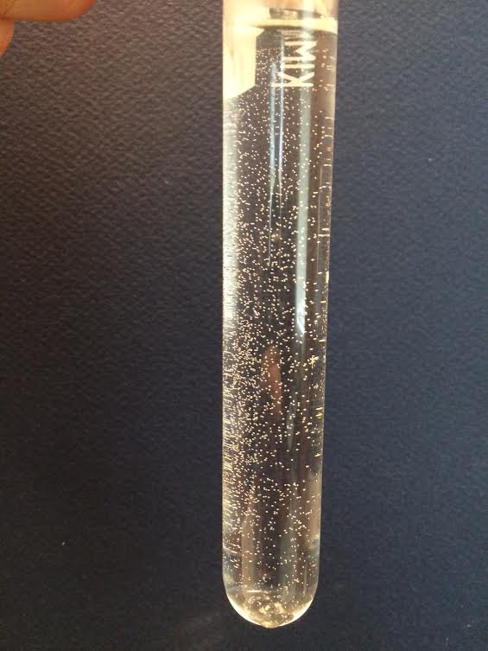
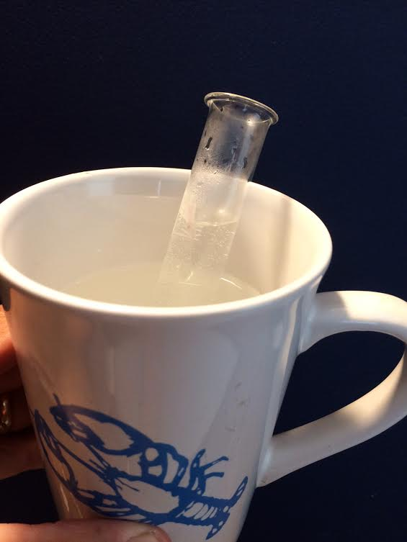
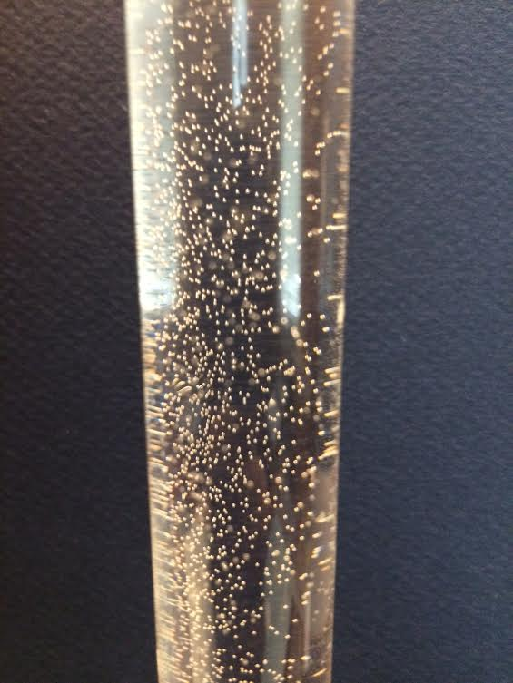
Test tube with Test tube placed After heating, the water in test tube has cold tapwater. in hot water bath. gases that came out of solution as bubbles.

