Press Release: Life expectancy rises in Massachusetts, breaking with national trend
12/26/2018
- Department of Public Health
BOSTON — The average life expectancy of Massachusetts residents rose to 80 years and 8 months in 2016, an increase in longevity that runs counter to national trends showing a decline in how long Americans are expected to live.
Since 2006, life expectancy in Massachusetts has remained close to 80 years, reaching 80 years and 11 months at its highest in 2012-2013, according to the Massachusetts Deaths 2016 report released today by the Department of Public Health (DPH). In 2015, life expectancy for residents was 80 years and 5 months.
``Massachusetts has worked hard to have near universal health care coverage that promotes health and we consistently rank as one of the healthiest states in the nation. This report shows that working together at both the state and municipal level, and with our health care partners, we can improve the health and well-being of all Massachusetts residents,” said Health and Human Services Secretary Marylou Sudders. “As people live longer, we must continue taking steps to position the Commonwealth as an age-friendly state, which is why we created the Governor’s Council to Address Aging. We recognize that we have more to do, especially in bringing an end to the opioid crisis which has had such a deadly impact across the state.”
In 2016, Hispanic women in the Commonwealth had the highest life expectancy, living, on average, to age 89. The life expectancies for white non-Hispanic women and black non-Hispanic women also were higher than the estimate for Massachusetts residents overall at 82 years and 11 months and 83 years and 7 months, respectively.
Overall, there were 832 fewer deaths in Massachusetts in 2016 compared to 2015; the age-adjusted mortality rate dropped from 684.6 deaths per 100,000 people in 2015 to 668.9 deaths per 100,000 in 2016. The death rate declined for white non-Hispanics, Asian non-Hispanics, and Hispanics; for black non-Hispanic residents, the death rate increased.
Cancer was the leading cause of death for Massachusetts residents in 2016, with lung cancer remaining the leading cause of all cancer deaths. The rate of cancer deaths was highest for white non-Hispanic residents (154.3per 100,000) and lowest for Hispanic residents (91.7 per 100,000).
``A major focus for us in public health is closing the gap in health disparities – and this annual report plays a key role in helping us to shape our prevention efforts so they are targeted where they are most needed to reduce those disparities,” said Public Health Commissioner Monica Bharel, MD, MPH.

(The following is excerpted from a Boston University Study, “Health and the City” )

Health and Boston
Perhaps the abstraction of “urban health” is brought home more acutely when one considers our home, Boston. Boston is characterized by dramatic heterogeneity in health across the city. Life expectancy in this relatively small city varies by as much as 33 years between neighborhoods that are only a couple of miles away from each other, with a high of 91.9 in Back Bay and a low of 58.9 in Roxbury. Comparably, Jarvis Chen and colleagues compared premature mortality rates across neighborhoods in Boston, finding that Roxbury and South Boston had by far the highest rates and Back Bay/Beacon hill had the lowest (see figure below).

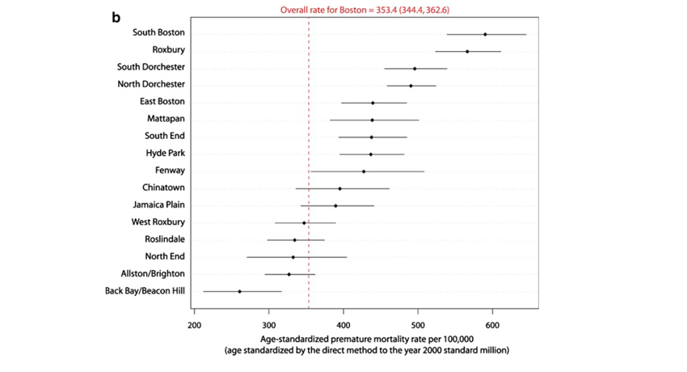

*Note: Premature mortality is a measure of potential life expectancy lost.

