Special Properties of Water

Lesson 2. The “Stickiness of Water”
Cohesion, Adhesion, and Surface Tension

Introduction

When describing water, we often hear one say that water is “wet.” Well this is true, as water sticks to a lot of materials and hangs on. Water is sticky. It takes a lot to dry out water soaked clothing or wet hair as water sticks to these materials. Water also sticks to water very well, it is very cohesive. We have raindrops and huge bodies of liquid water at a wide range of temperature.

The extraordinary stickiness of water is due to the composition and shape of the water molecule. Each water molecule has two hydrogen atoms and one oxygen atom, H₂O. Hydrogen atoms have only one negatively charged electron orbiting just one positively charged proton. Since the Oxygen atom has 8 protons it tends to pull Hydrogen’s
electrons toward the inside of the water molecule, toward the Oxygen atom. This leaves the Hydrogen atoms with a slight positive charge and the Oxygen atom with a greater negative charge. The result is a “polar molecule” where the Hydrogen side of the molecule has a positive charge and the Oxygen end of the molecule negatively charged.

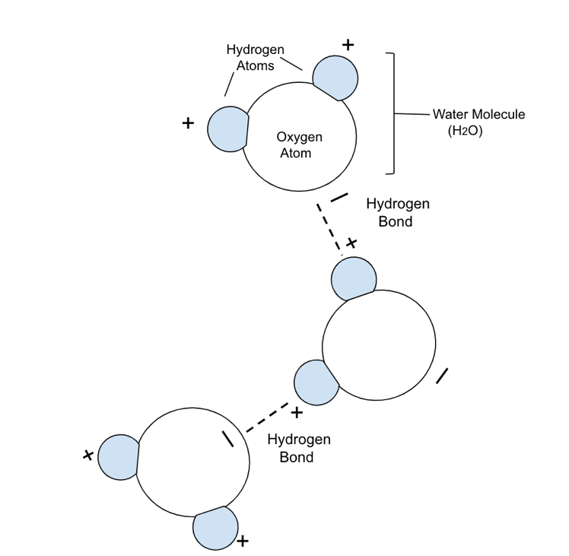

If we could see molecules of water, we would see that each water molecule is attracted to others with their Hydrogen (+) side pulling on the Oxygen(-) end of a neighboring molecule. This force forms a bond between the molecules known as a “Hydrogen bond” which holds water molecules together and results in their cohesive properties.

This pull also makes it difficult to separate these molecules to go from the liquid state to gas. It requires a lot of energy to evaporate water.

If water were not this shape and a polar molecule it
wouldn’t exist in the liquid state at temperatures that
we experience on Earth. It would be just another gas.

Background terms and phenomena

Cohesion (Pronounced “Co- HEE- shun”)- The pull between molecules of the same material.
ex: Water molecules stick together to build a raindrop.

Adhesion Pronounced “add- HEE- shun”)- The pull between molecules of different materials.

ex: Water drops stick to glass. Water clings to the fibers in clothing or paper.
This is why water is often referred to as “wet”… and why things become “wet.”
Capillary Action

The pull between water and other materials may cause water to climb UP into a narrow tube, the tiny spaces in a paper towel, or the stem of a plant. This is known as Capillary Action. This phenomenon is a combination of
water’s strong adhesive and cohesive properties.

Surface Tension

Have you ever seen insects walking or skimming on the surface of a pond? Why does water “bead up” on some surfaces rather than spread out flat? Why can you fill a cup above the rim? The answer is a property in liquids called Surface Tension. With the exception of Mercury, no other liquid has a stronger surface tension than water.

Surface Tension is a phenomenon where a layer of tightly bonded molecules occurs at the surface of a liquid creating “a skin” that holds drops of a liquid together, can support objects on its surface, and prevent some materials from breaking through and sink. Since the cohesion between water molecules is unusually strong, the surface tension we see in water is powerful.

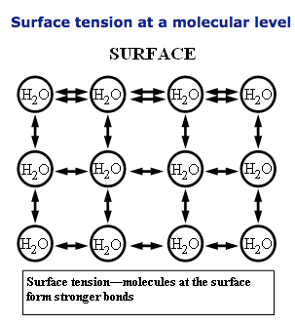
Water molecules throughout a liquid pull on each
other in different directions due to their cohesion,
but at the surface, where molecules are in contact
with the air and have no water molecules above
them they pull on their adjacent molecules with
extra force.

Image at the right is from USGS Water Science School.
https://water.usgs.gov/edu/surface-tension.html

Suggested resources to enhance this lesson:

Water: A Polar Molecule. https://www.youtube.com/watch?v=iOOvX0jmhJ4. Bozeman Science.com. March 14, 2014.

PhET Interactive Simulations for Science and Math. University of Colorado Boulder. Molecular Polarity.
https://phet.colorado.edu/en/simulation/legacy/molecule-polarity.

Hands-on Activities and Demonstrations:

The following activities will demonstrate the properties of cohesion and adhesion as well as the phenomena of capillary action and surface tension of water.

Materials :

• water • droppers or pipettes • magnifying glass • clean unused plastic petri dish or plastic plate

• small plastic cups • test tube with holder •food coloring • paper towels/tissue

• steel paper clips • diluted dishwashing liquid • capillary tubes (optional)

Activities and Demonstrations:

1. Using a dropper with water, place a few drops on top of each other onto the petri dish.

• What shape is this drop ? ... is it flattened or does it “bead up?”

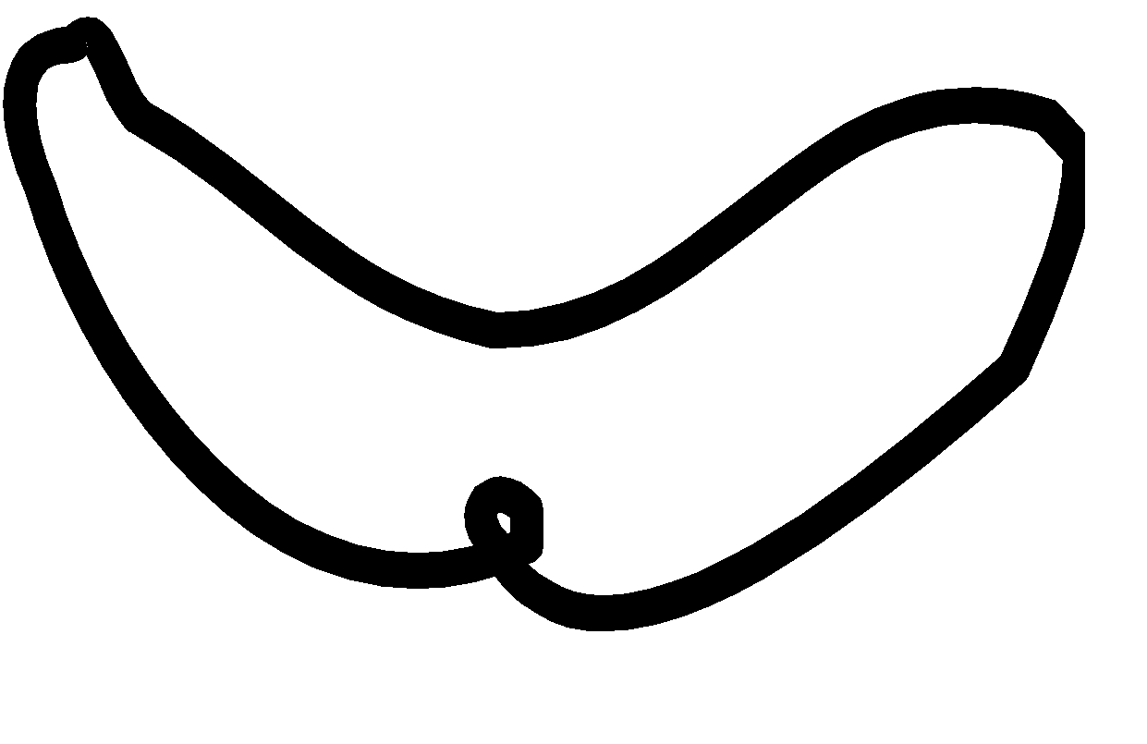
2. With a dropper or pipette, make a “happy-face” using droplets
of water in the petri - dish.
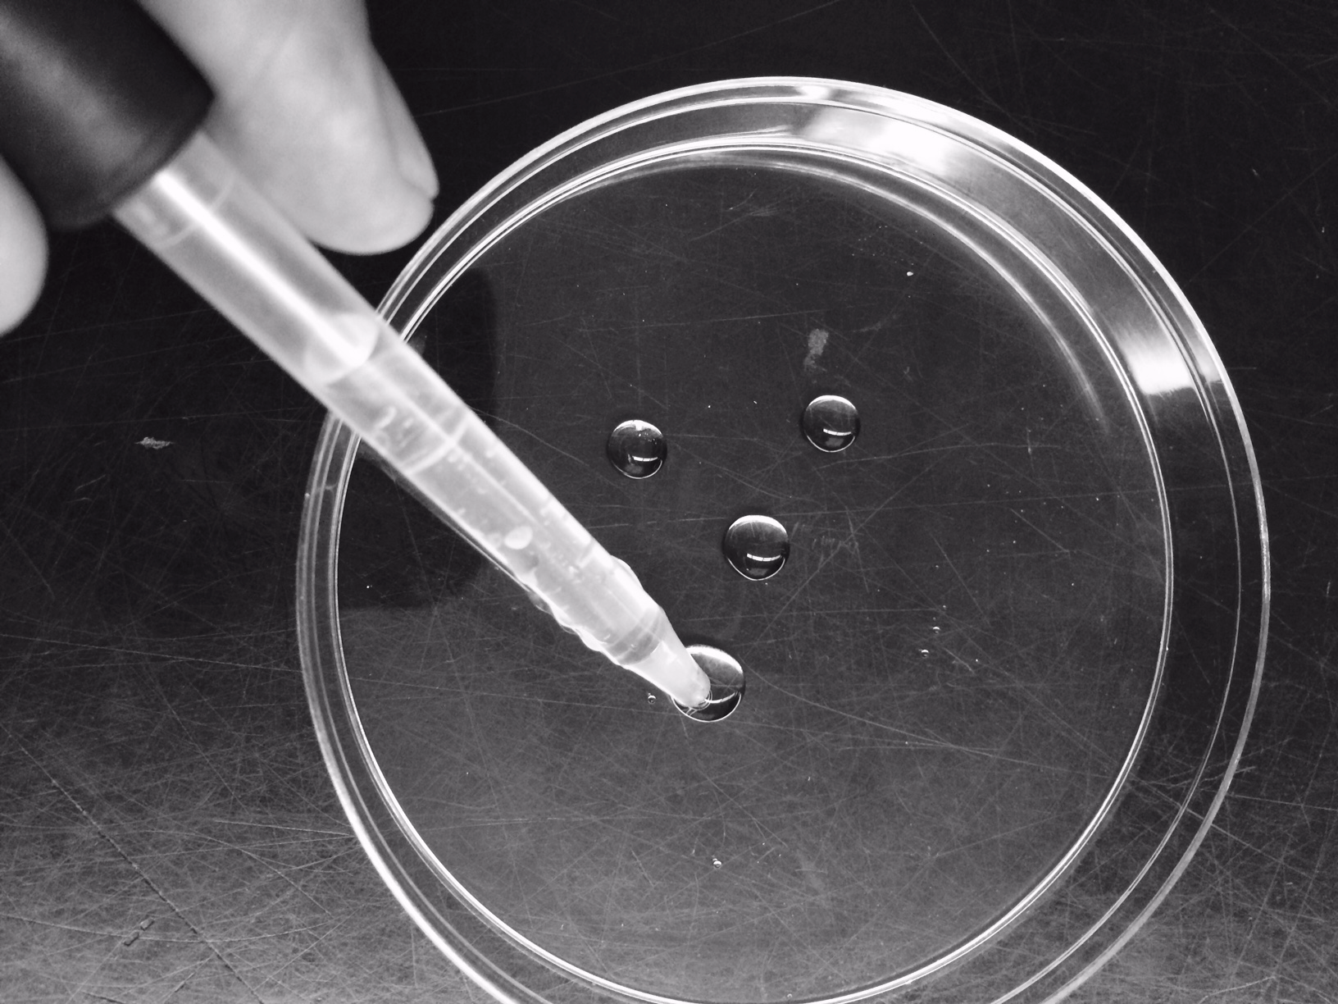

Why is it so hard to make the mouth smile?

_______________________________________________________________

_______________________________________________________________

What property of water is being shown with this demonstration? _______________________

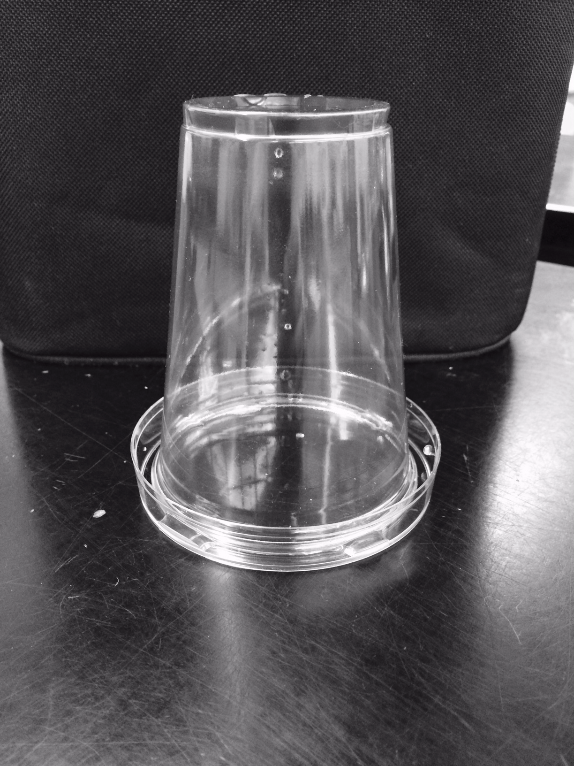
3. Invert a small cup in the petri dish so that the water spreads
around the rim.... you may need to spin the cup around to
make sure that there is a thin even layer of water between
the rim of the cup and dish.

• Without breaking the water seal between the cup and dish,
drain off any excess water turn the petri dish and cup
the opposite way as shown.

• Lift the petri dish. Do the cup and dish stay together? _______

• Gently shake the dish. What happens?

_____________________________________________________

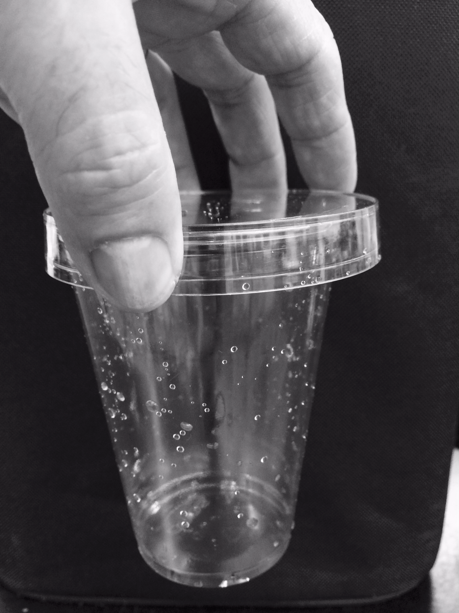
• What properties of water does this demonstrate?

__________________________________________________________

• Explain your answer

___________________________________________________________

___________________________________________________________
________________________________________________________________________________________

4. Fill a small test tube with water until it is almost completely full.

• Make a prediction about how many more drops will
fit into the tube before it overflows. Try it.

How many fit? _________

• What property of water is shown by this demonstration?

________________________________

•What phenomenon is being demonstrated here as a result of
this property of water?

__________________________________________________
5. Floating a steel paper clip on the surface of water.

Fill another cup with water. Balance a paper clip flat across a bent paper clip.
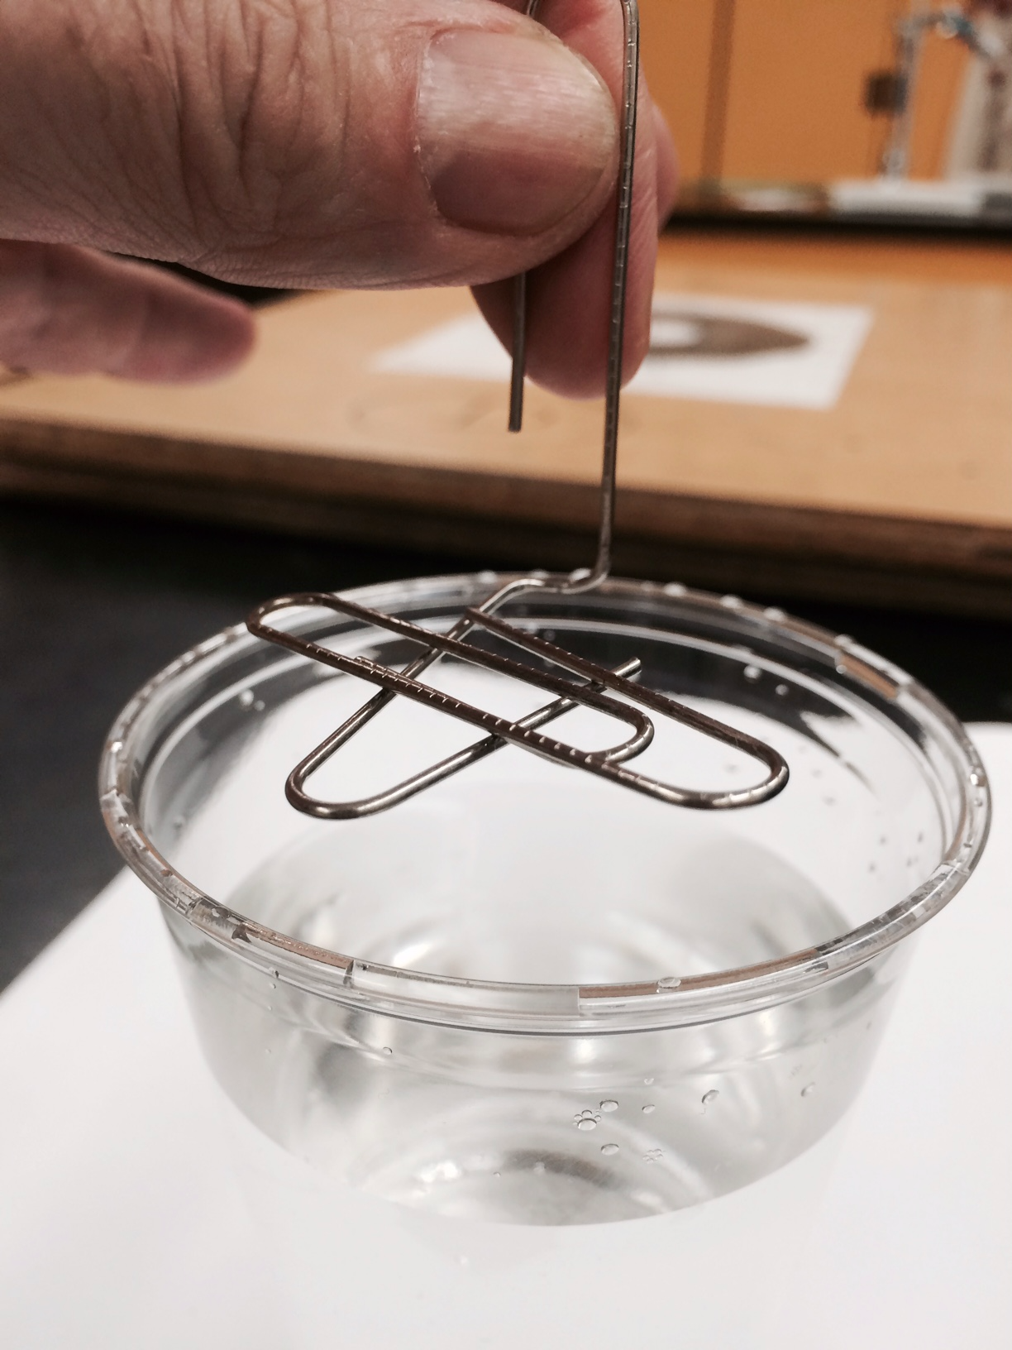

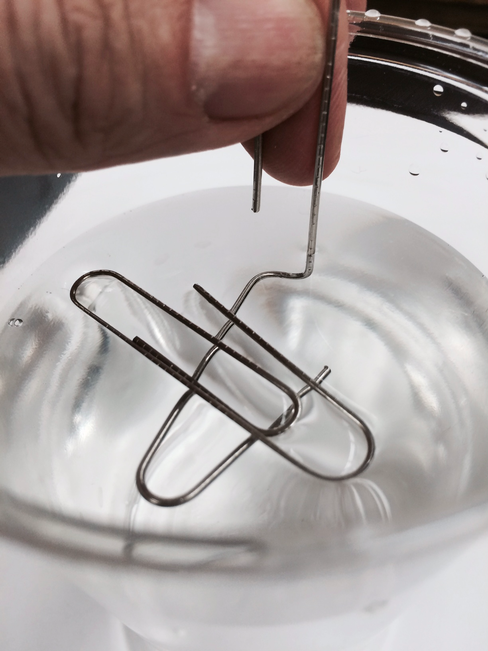

Next , using the bent clip and a holder,
SLOWLY lower the paper clip into the cup of
water and lay it flat on the water’s surface.

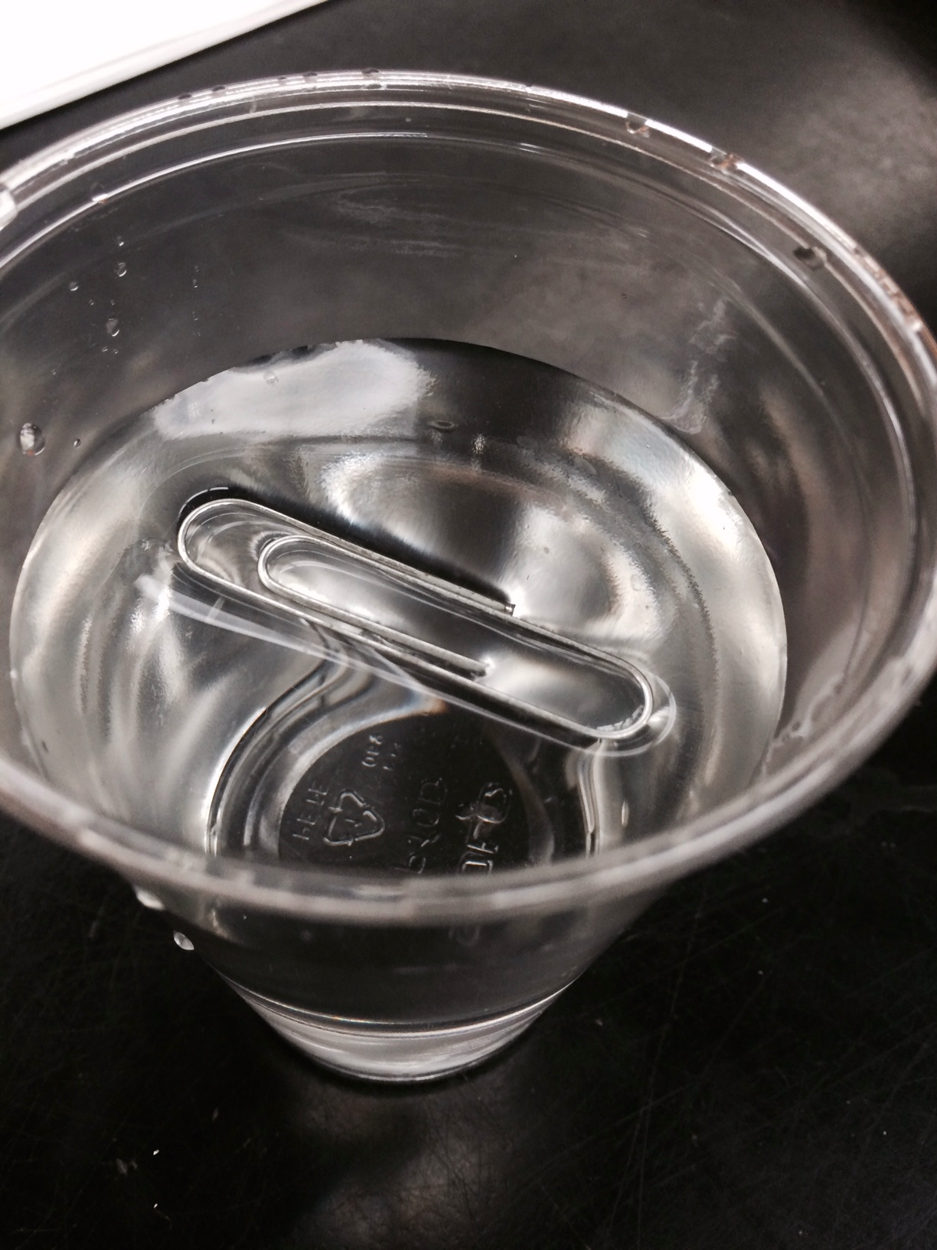

Did you get it to float? _________
What phenomenon of water does this demonstrate?

________________________________________________________________

What happens to the paper clip when a drop of dilute dishwashing liquid is added to the water in the cup?

_____________________________________

How does this change the properties of water?

____________________________________________________________________________________________

Soaps and Detergents

Soaps and detergents weaken water's surface tension, thus allowing water and the cleaning agent to penetrate into the pores of soiled materials.

Don't touch the tent!

Common tent materials are somewhat rainproof in that the surface tension of water will bridge the pores in the finely woven material. But if you touch the tent material with your finger, you break the surface tension and the rain will drip through.

Washing with cold water

The major reason for using hot water for washing is that its surface tension is lower and it is a better wetting agent. But if the detergent lowers the surface tension, the heating may be unnecessary.

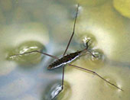
A “Water Strider” is able to glide on the surface of a pond
without breaking through the surface because of the water’s
surface tension.

Photo from USGS Water Science School. Surface Tension
and Water. https://water.usgs.gov/edu/surface-tension.html

Think About this...

What could happen to these insects and others like them, when ponds become polluted with detergents ?

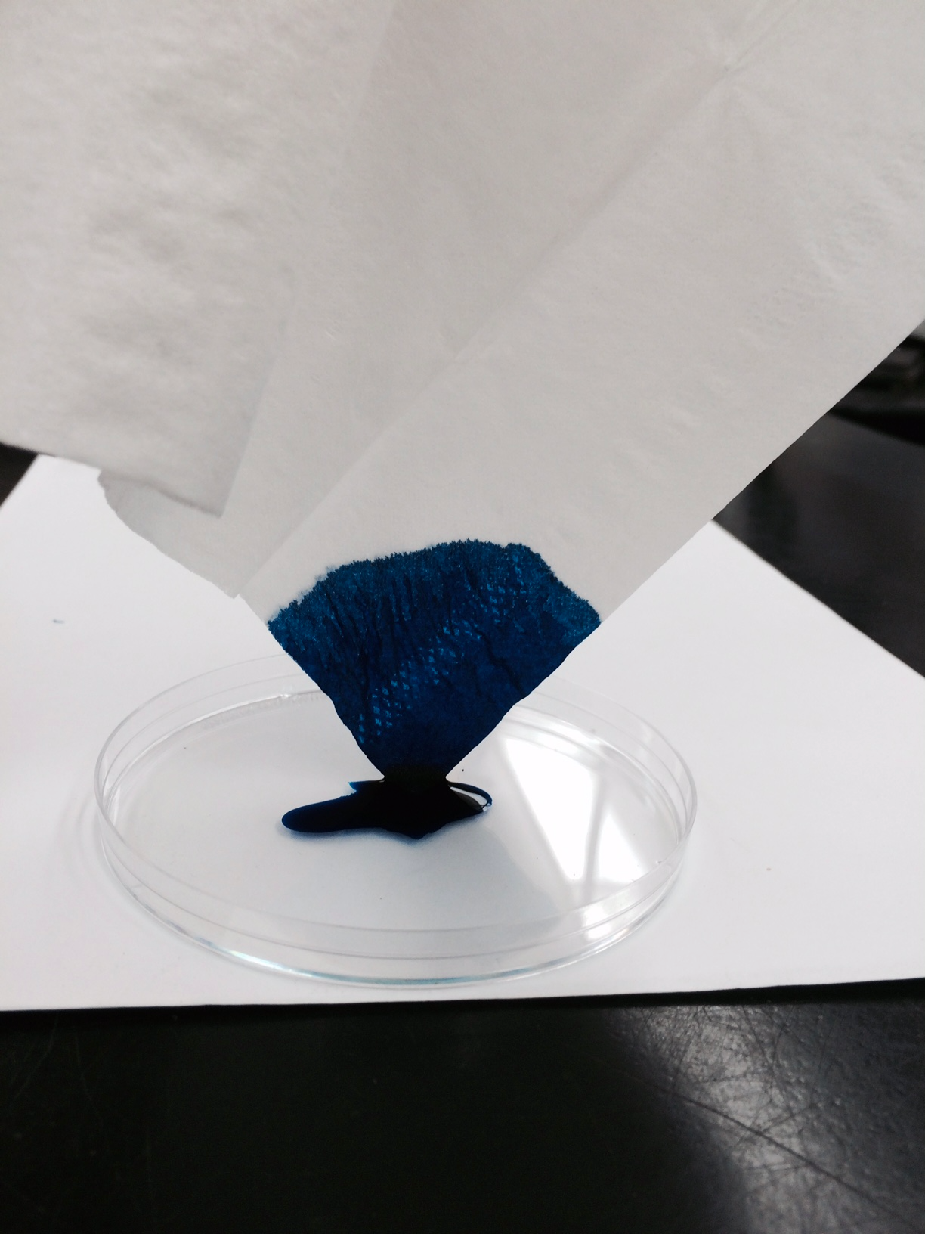
6. To demonstrate the phenomenon of capillary action you can
simply dip a tissue or paper towel into a large drop
of water with food coloring.

Notice how the colored water climbs up the paper against
the force of gravity. The adhesive force of the paper fibers
must be greater than the force of gravity.

Why does the liquid eventually stop climbing up the paper?

________________________________________________

________________________________________________

________________________________________________

Capillary tubes are tubes with a very tiny internal diameter and are used to move fluids with capillary action.

When the internal diameter of the tube is very small, the ratio of surface for adhesion is greater than the volume of water in the tube. Thus the force of adhesion is greater than the gravitational pull on the water so it climbs higher in this narrow tube.

When tubes are microscopically thin such as the bundles of xylem in plants, capillary action is strong enough for water to climb to the tops of very tall trees.

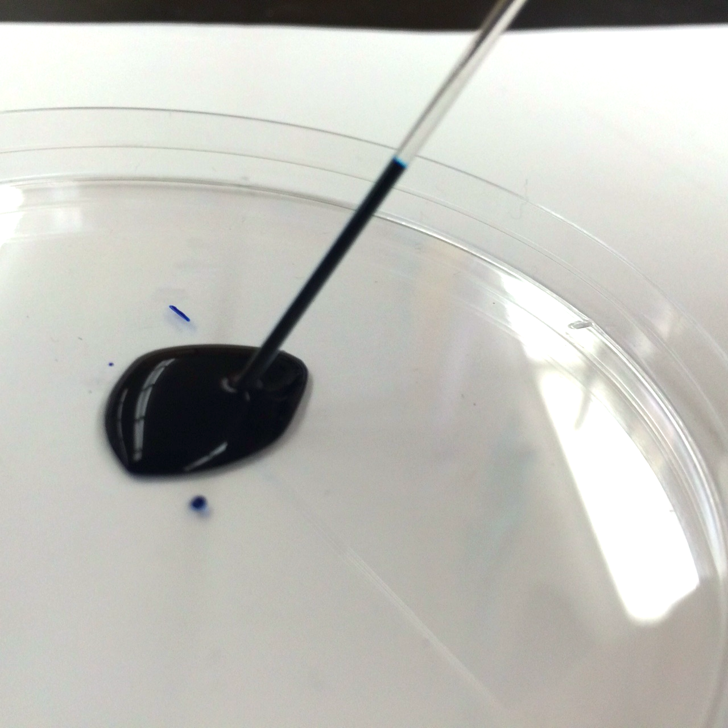

Water with food coloring is pulled up a glass capillary tube with the force
of adhesion.

