Special Properties of Water

Lesson 1: Water is the “Universal Solvent”

One of the more important properties of water, especially when it comes to the survival of living things, is water’s ability to dissolve a wide variety of materials from solids to gases. With this ability, water has earned the nickname: “the universal solvent.”

Background Vocabulary:

•Dissolve: when a solvent physically breaks a substance down into its individual molecules or atoms, which
spread throughout the solvent

Materials are dissolved in water when the solution is clear. You cannot see them as they are broken down into separate tiny particles: molecules, atoms, or which are invisible.

Simple Rule: If you can see it------then it is NOT dissolved.

•Ions: atoms or molecules with a net electric charge due to the loss or gain of one or more electrons

•Ionic Bonds: chemical bonds formed between positive and negative ions, which happens when
electrons are exchanged between atoms to complete their outer shells of electrons;
negative ions attract positive ions which hold atoms together to form molecules.

Compounds formed from ionic bonds happen when the atoms of metals chemically bond with
atoms of non-metals.

•Molecules: particles formed when two or more atoms are chemically combined in a very specific
combination; the tiniest particles of a compound that still can be that compound are its
molecules

•Solvent: a liquid that dissolves materials…. like water

•Solution: a mixture of materials dissolved in a solvent… like seawater.

•Solute: a material that is dissolved in a solvent… like salt or sugar

Not only can water dissolve many substances, but once they’re dissolved, water keeps these materials in solution and water is chemically unchanged when this happens. In this way water can move or transport dissolved materials, which is so important for living things.

The Shape of the Water Molecule

Water’s ability to dissolve so many substances is due to the shape and structure of its molecules. Water molecules have an unequal arrangement of electrons as there are more electrons near the Oxygen atom giving that side a negative charge. At the end of the molecule, where the Hydrogen atoms are located, there is a positive charge. This results in the water molecule being a “polar” molecule with a positive end and a negative end.

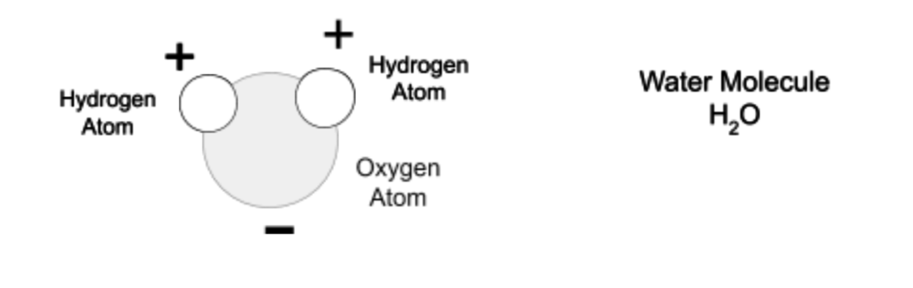

Since water is a polar molecule, it is especially good at dissolving compounds formed with ionic bonds such as the salt, Sodium Chloride. Water dissolves this compound by breaking up its ionically bonded molecules into their ions.

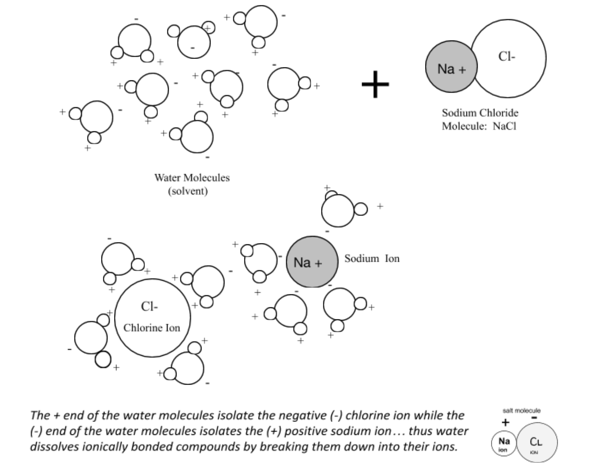
-
How is water able to dissolve so many materials?

Lab Demonstration: Charged Atoms in Water

When certain materials are dissolved in water they can produce a solution that can conduct electricity.

In this lab demonstration, we will look at different solutions of some common compounds dissolved in water and test their ability to conduct electricity. Our results will help us to gather evidence for how water is able to dissolve certain materials and indirectly prove the existence of ions and ionic bonds.

Materials: 9V Battery, light bulb, wire leads with alligator clips, paper clip electrodes, beakers or clear
cups, spoons, table salt (Sodium Chloride), table sugar, and water, Periodic Table of Elements.

Compare the diagram with our actual set-up. Make sure that you understand how this set-up works.

Important Background:

Vocabulary:

•Ions: atoms or molecules with a net electric charge due to the loss or gain of one or more electrons

•Ionic Bonds: chemical bonds formed between positive and negative ions, which happen when
electrons are exchanged between atoms to complete their outer shells of electrons;
negative ions attract positive ions which hold atoms together to form molecules.

Compounds formed from ionic bonds happen when the atoms of metals chemically bond with
atoms of nonmetals.

•Molecules: particles formed when two or more atoms are chemically combined in a very specific
combination; the tiniest particles of a compound that still can be that compound are its
molecules

•Covalent Bonds: bonds that join the atoms to form molecules when pairs of electrons are shared to
have complete outer shells of electrons

Compounds formed from ionic bonds happen when the atoms of nonmetals chemically bond .

Informational text:

An electric current is a flow of electrical charge. When a metal conducts electricity, the charge is carried by electrons moving through the metal. When a solution conducts electricity, the charge must be carried by particles moving through the solution. These particles must have an electrical charge. Some must have a negative charge and some have a positive charge…in other words... “ions.” So.. there must be ions dissolved in water for a solution to conduct electricity!

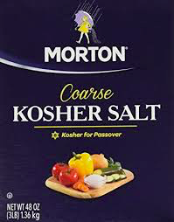
Experiment #1: Sodium Chloride (NaCl) “table salt” dissolved in water.

- Test the conductivity of dry salt crystals by placing the paper clip electrodes into
a small amount of salt. Does it conduct electricity ? ______

2. Dissolve a spoonful of salt in a beaker of water and stir until it is completely dissolved.

Does the salt solution conduct electricity? _______ Then, were there + and - charged particles
(ions) released into water? ________

3. Using your periodic table... What type of element is Sodium : metal or nonmetal ? _________

What type of element is Chlorine : metal or nonmetal ? ___________________

Analyzing our results: Water breaks the ionic bonds between Sodium and Chlorine ions when
dissolving Sodium Chloride (NaCl)
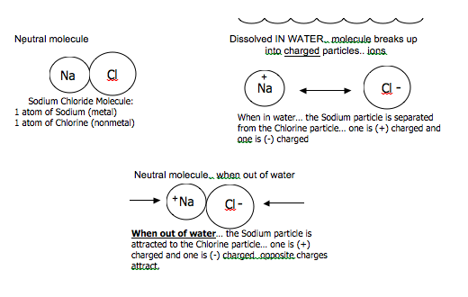

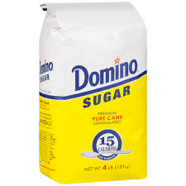
Experiment #2: Sugar (Sucrose) (C₁₂H₂₂O₁₁) dissolved in water.

- Test the conductivity of dry sugar crystals. Does it conduct electricity ? ______

2. Dissolve a small amount of Sugar in a beaker of water and test its conductivity.

Does the solution conduct electricity? _______

3. Then, does sugar release charged particles (ions) when dissolved in water? _____

4. a) Could sugar molecules be formed from the bonding of + and – ions? ______

How do we know? _____________________________________________________________

_____________________________________________________________________________

b) Does water dissolve sugar in the same way that it does salt and other ionically bonded
compounds? _____________________________

c) So does sugar dissolve in the same way as ionically bonded molecules like salt? _____

Sugar molecules are organic molecules made of the non-metals: Carbon, Hydrogen, and Oxygen. The atoms in organic molecules like sugar are held together by covalent bonds not ionic. But like salt, sugar dissolves easily in water. This is because sugar molecules (not their atoms) are held together by + and - forces from Hydrogen and Oxygen atoms in the sugar molecule. Thus, water dissolves sugar by separating its molecules not by separating ions.

To help better understand this lesson, explore the following simulation : Sugar and Salt Solutions . PHET Interactive Simulations from the University of Colorado at Boulder. (images from this simulation are shown below).

https://phet.colorado.edu/en/simulation/sugar-and-salt-solutions

Part 1: Conductivity of salt vs. sugar in solution.
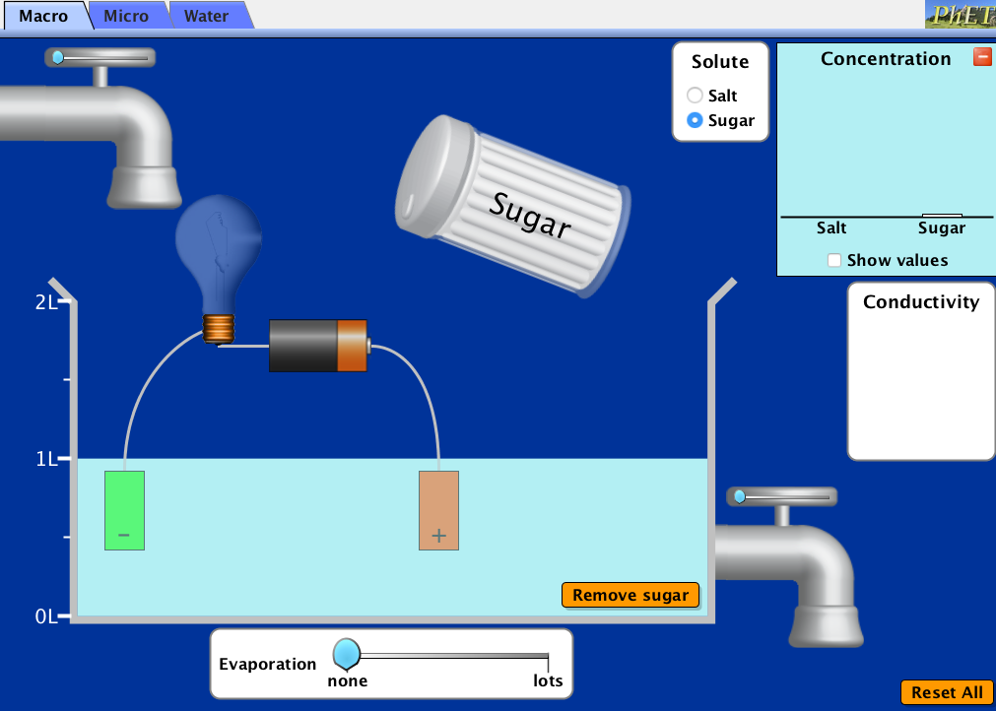
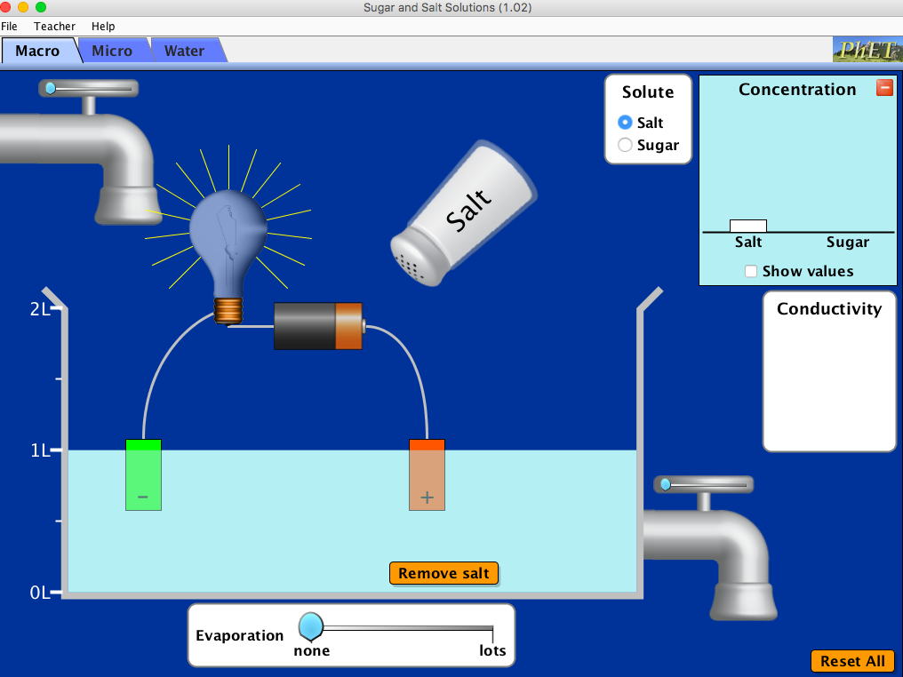

Parts 2 and 3 compare the dissolving of sugar in water at the molecular level.
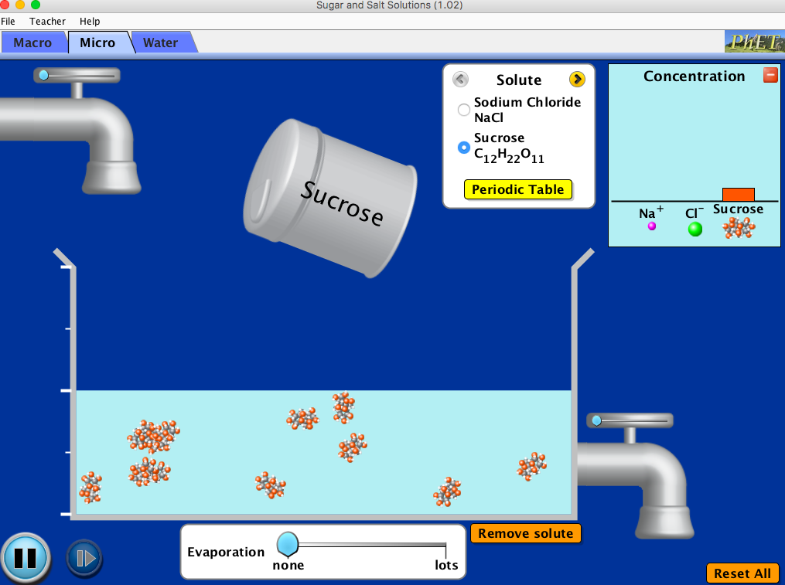
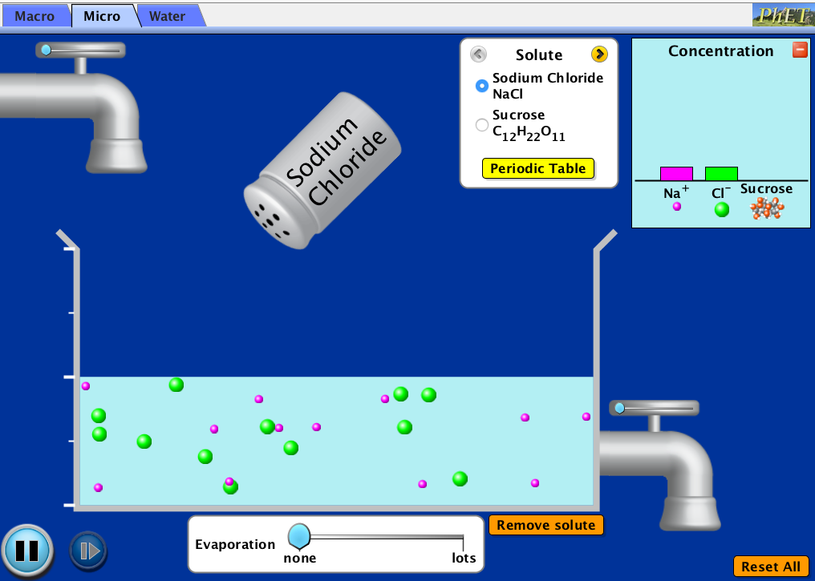

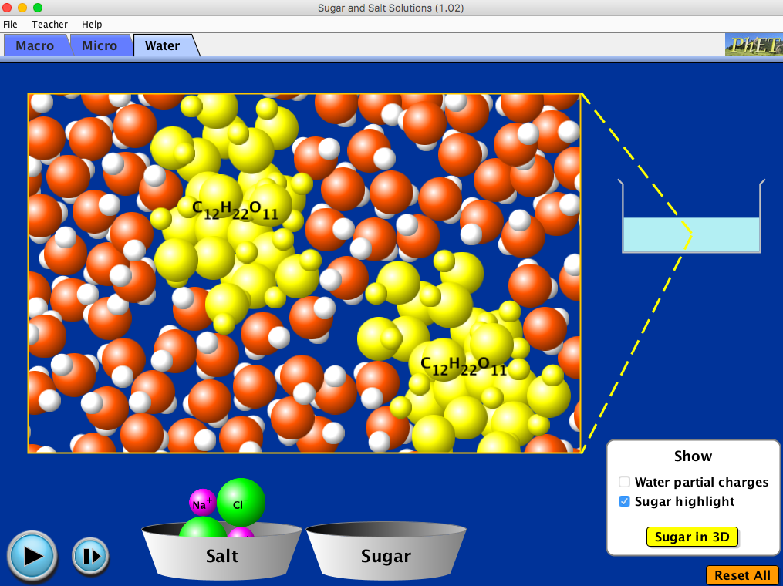
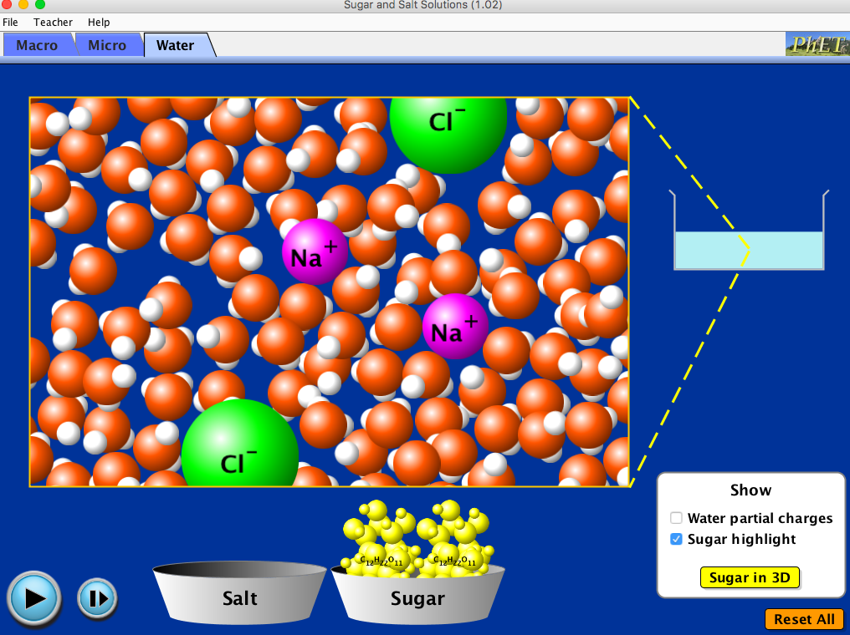

Lab Demonstration: Dissolved Gases in Water

