Special Properties of Water

Lesson 1: Water is the “Universal Solvent”

One of the more important properties of water, especially when it comes to the survival of living things, is water’s ability to dissolve a wide variety of materials from solids to gases. With this ability, water has earned the nickname: “the universal solvent.”

Background Vocabulary:

•Dissolve: when a solvent physically breaks a substance down into its individual molecules or atoms
spread throughout the solvent

Materials are dissolved in water when the solution is clear. You cannot see them as they are broken down into separate tiny particles: molecules, atoms, or which are invisible.

Simple Rule: If you can see it..... then it is NOT dissolved.

•Ions: atoms or molecules with a net electric charge due to the loss or gain of one or more electrons

•Ionic Bonds: chemical bonds formed between positive and negative ions which happen when
electrons are exchanged between atoms to complete their outer shells of electrons;
negative ions attract positive ions which hold atoms together to form molecules.

Compounds formed from ionic bonds happen when the atoms of metals chemically bond with
atoms of non-metals.

•Molecules: particles formed when two or more atoms are chemically combined in a very specific
combination; the tiniest particles of a compound that still can be that compound are its
molecules

•Solvent: a liquid that dissolves materials…. like water

•Solution : a mixture of materials dissolved in a solvent… like seawater.

•Solute: a material that is dissolved in a solvent… like salt or sugar

Not only can water dissolve many substances, but once they’re dissolved, water keeps these materials in solution and water is chemically unchanged when this happens. In this way water can move or transport dissolved materials, which are so important for living things.

The Shape of the Water Molecule

Water’s ability to dissolve so many substances is due to the shape and structure of its molecules. Water molecules have an unequal arrangement of electrons as there are more electrons near the Oxygen atom giving that side a negative charge. At the end of the molecule, where the Hydrogen atoms are located, there is a positive charge. This results in the water molecule being a “polar” molecule with a positive end and a negative end.

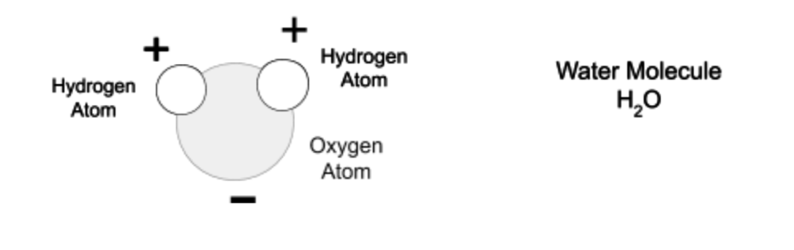

Since water is a polar molecule, it is especially good at dissolving compounds formed with ionic bonds such as the salt, Sodium Chloride. Water dissolves this compound by breaking up its ionically bonded molecules into their ions.




