Activity 6:
Based on a given graph, analyze the graph of blood glucose levels against time to find out the relationship between the Glycemic Index (GI) and the rate of carbohydrate increasing glucose in the blood.
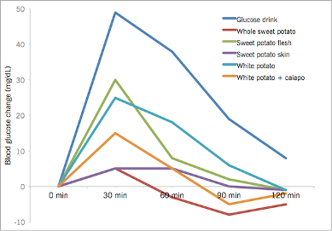
Figure 1: Graph of Blood Glucose Change vs Time
Answer the following questions:
- Will you be able to choose food with a high Glycemic Index?

- Why is food with a high Glycemic Index not suitable to be eaten on the race day?

Activity 7:
From the given Table A and Table B, mix and match ingredients of you recommended energy bar for marathoners. Choose from the three categories: Cereal, Dried fruit, Nuts and extras.
You will have to follow instructions given by the teacher and design your own energy bar for marathoner. You will also have to explain on the relevance of the ingredients used in their energy bar.
Table A:
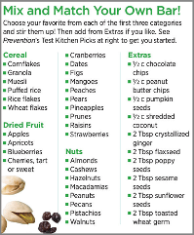

Table B:

Dried fruit caloric table
Product | Quantity | Energy (kcal) | Protein (g) | Fat (g) | Sugar(g)
Almonds | 100 g | 572 | 20,0 | 52,0 | 20,5
Cashews | 100 g | 633 | 25,2 | 53,6 | 12,6
Cedar nuts | 100 g | 629 | 12,0 | 61,0 | 12,0
Coco nuts | 100 g | 380 | 3,4 | 33,5 | 29,5
Dried apples | 100 g | 238 | 2,1 | 2,1 | 62,3
Dried apricots | 100 g | 284 | 5,4 | 1,2 | 72,2
Dried apricots with stone | 100 g | 227 | 5,0 | 0,0 | 53,0
Dried bananas | 100 g | 390 | 3,9 | 1,8 | 80,5
Dried briar fruit | 100 g | 110 | 3,4 | 0,0 | 21,5
Dried dates | 100 g | 277 | 2,0 | 0,4 | 74,0
Dried figs | 100 g | 290 | 3,6 | 1,2 | 78,0
Dried peach | 100 g | 254 | 3,0 | 0,4 | 57,7
Dried pears | 100 g | 270 | 2,3 | 0,6 | 62,6
Hazelnuts | 100 g | 640 | 14,4 | 63,0 | 14,9
Hazelnuts | 100 g | 707 | 16,1 | 66,9 | 9,9
Mustard pits | 100 g | 474 | 25,8 | 30,8 | 23,4
Peanuts | 100 g | 560 | 25,7 | 46,1 | 19,2
Pecans | 100 g | 589 | 20,5 | 48,5 | 25,0
Poppy seeds | 100 g | 478 | 20,1 | 42,9 | 24,7
Prunes | 100 g | 267 | 3,5 | 1,2 | 68,9
Pumpkin seeds | 100 g | 556 | 24,5 | 45,8 | 18,0
Raisins | 100 g | 277 | 2,3 | 0,5 | 71,2
Roast chestnuts | 100 g | 182 | 3,2 | 2,2 | 33,8
Sesame seeds | 100 g | 565 | 19,4 | 48,7 | 12,2
Sunflower seeds | 100 g | 561 | 24,4 | 43,7 | 24,6
Walnuts | 100 g | 645 | 16,0 | 60,3 | 18,0

