Handout 2
Activity 6: What is the price of each feature?
Property Features Price
A House + Carporch + Pool 820,000
B House + Carporch 720,000
C House + Pool + Studio 900,000
D House + Studio + Garage 870,000
E House + Garage + Tennis Court 930,000
F House + Pool 780,000
Table 1

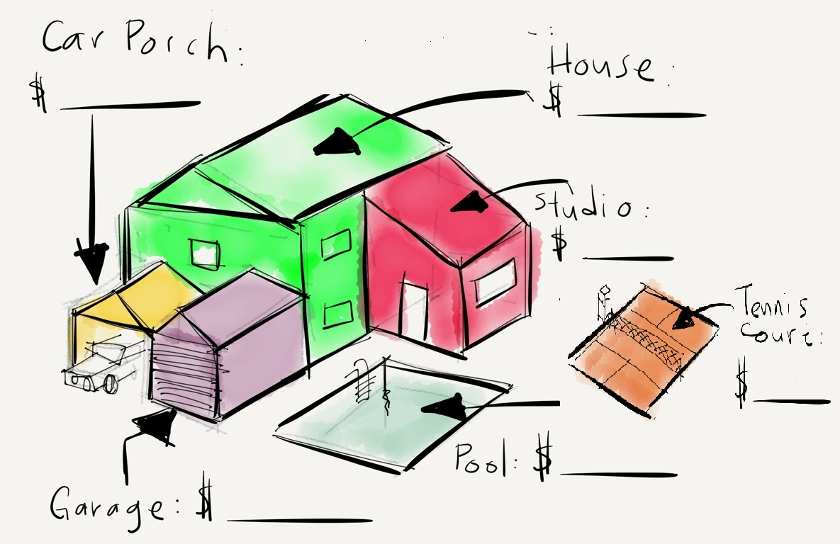

Figure 1
Given the equations in Table 1, what is the value of each feature in Figure 1?

