[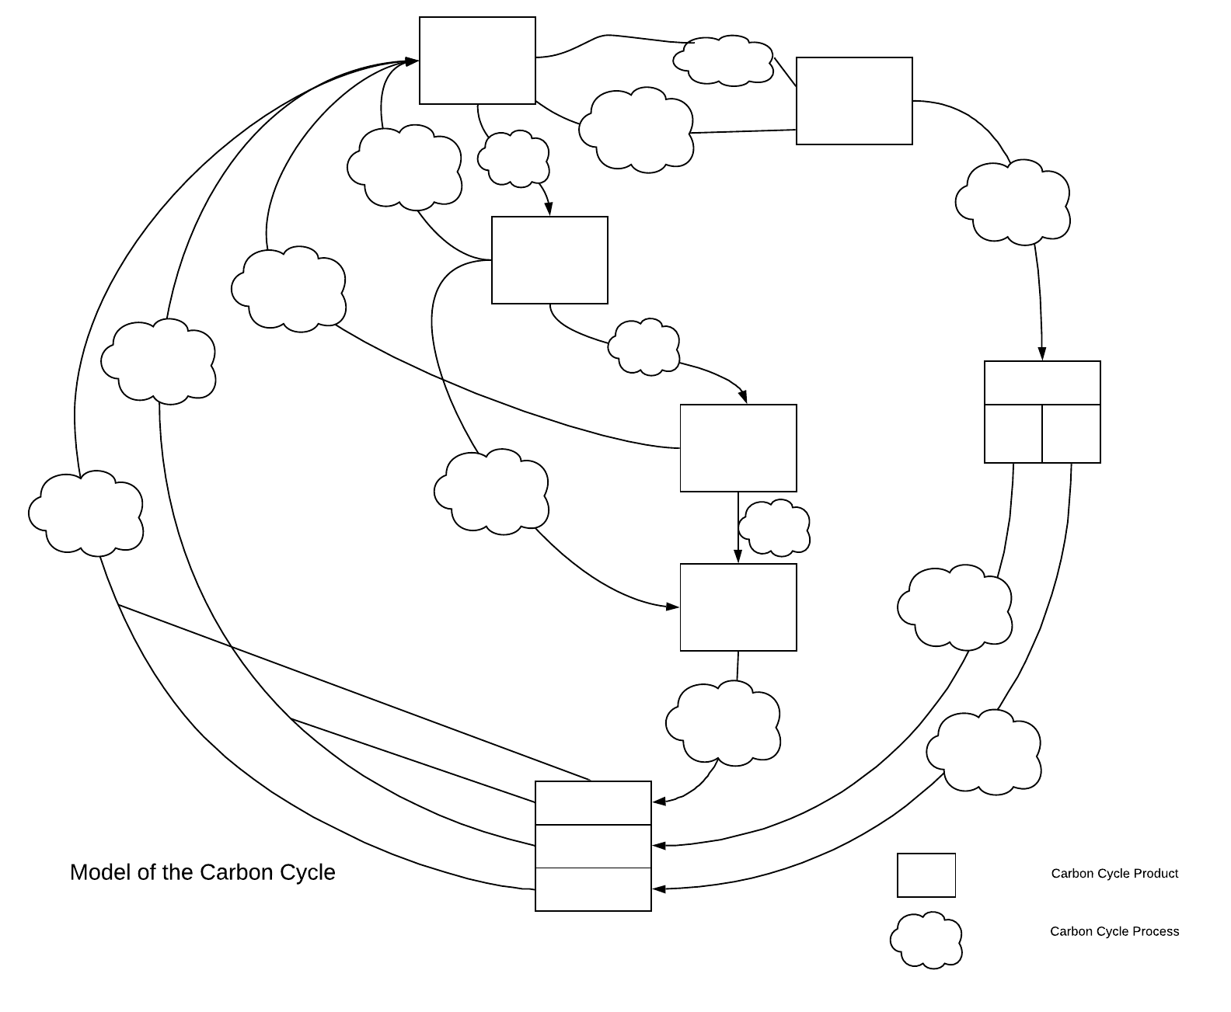](https://www.lucidchart.com/documents/edit/4bdb2bf4-718b-4335-9e0b-f7fb4e483e4b/0?callback=close&name=docs&callback_type=back&v=694&s=792)