[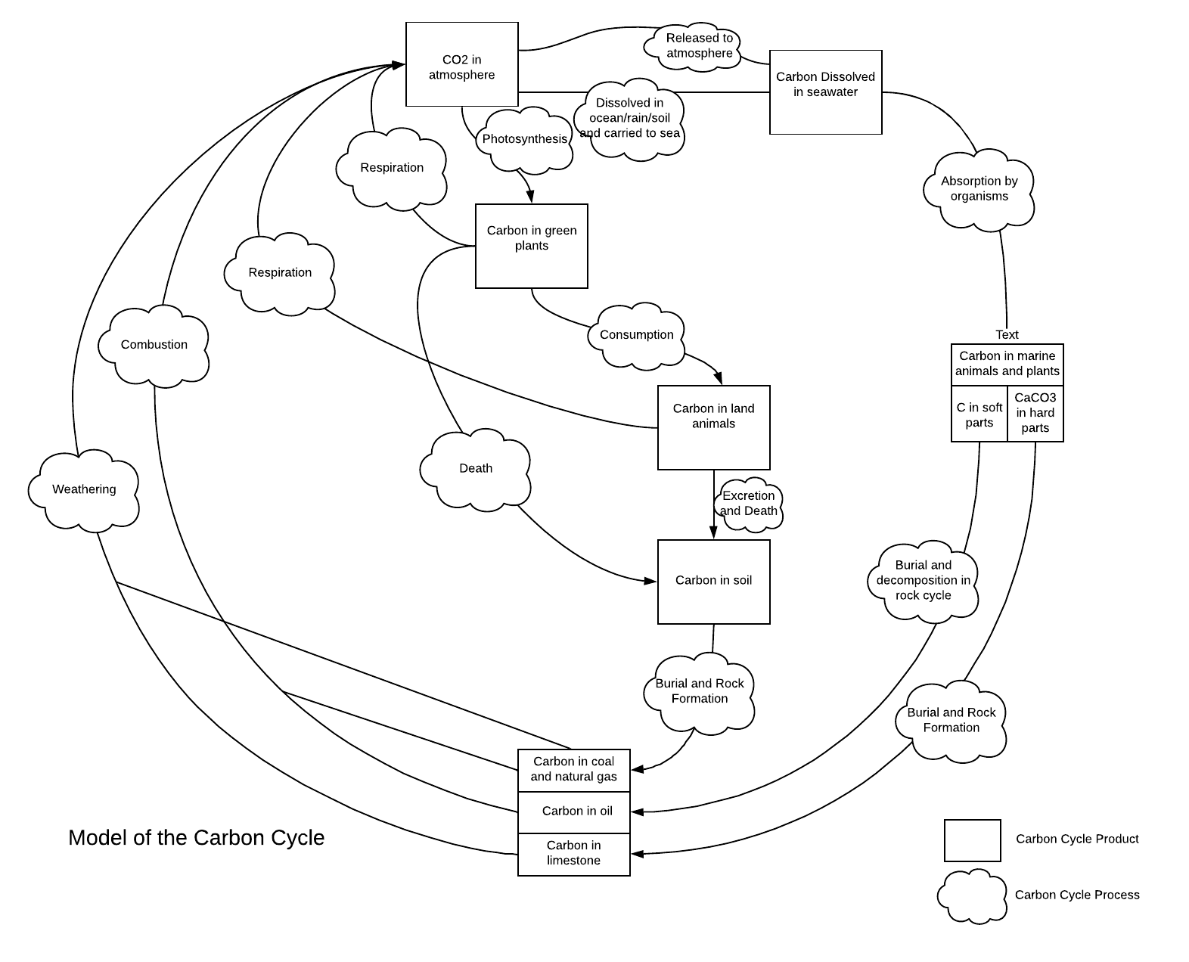](https://www.lucidchart.com/documents/edit/379d0a2f-3fbc-4c2a-b4d5-4bb61d39df51/0?callback=close&name=docs&callback_type=back&v=1438&s=786)