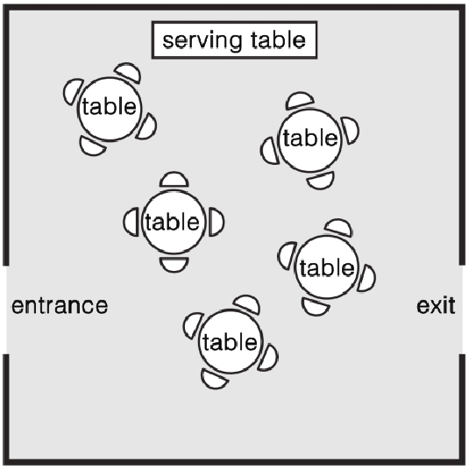

Instructions for Activity 1:

You must assume that the banquet has two doors, an exit and entrance. The wait staff cannot retrace their steps but must always move forward to avoid collision with another wait staff.
Your teacher will provide you with colour cards. In small groups, rearrange the cards as if you are structuring the food delivery to every table in the wedding room.

- 10 red cards represent waitresses
- 10 green cards represent waiters
- 10 blue cards represent tables in the hall

Your teacher will ask you to briefly explain your idea of structuring the food delivery based on the way you organize the color cards.

