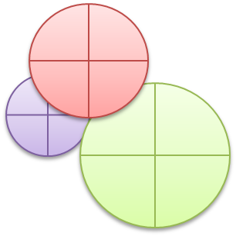
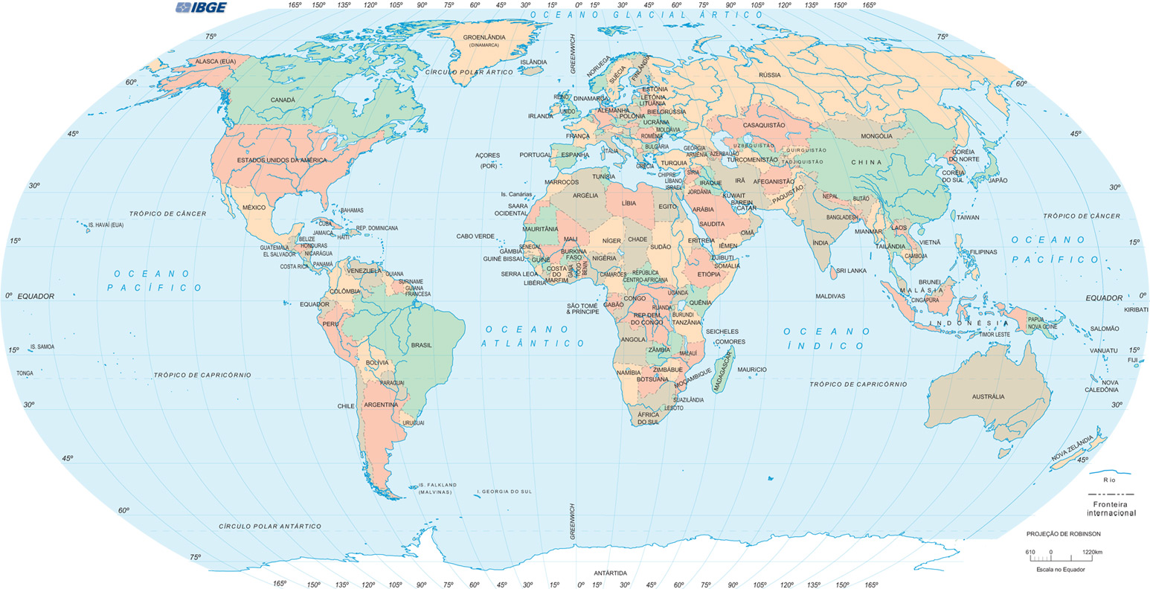
Tomado de https://vignette.wikia.nocookie.net/acam/images/8/8e/Mapa-mundi.jpg/revision/latest?cb=20130625151418&path-prefix=es
Solo con fines educativos

