Name: ______________________________________ Period: __________________
VARIATION WITHIN A POPULATION - TEACHER EDITION (WITH SAMPLE ANSWERS)
OVERVIEW
Evolution is a tough concept to understand. You probably realize that in every population there is variation. Nature acts upon variations. Certain types of individuals are selected for; other individuals must either migrate or die. This lab will show you that there is a variety of individuals in a population.

PERFORMING THE INVESTIGATION (check off each box after completing that step)

◻1. Pair off with another student, as directed by your teacher.
◻2. Make sure you have the following materials: a bag with at least 50 kidney beans, a ruler and a sheet of graph paper.
◻3. Now that you have your materials, describe what is in your bag (be creative and explicit). At this point, do NOT open the bag.

◻4. In which ways are individuals beans from your bag different from one another. Think of ways of separating the beans into groups.

◻5. Select two of the patterns or characteristics you described in part #4 (above) and physically separate the beans into two groups.
◻6. Now that you separated the beans into two groups (e.g. dark vs. light, long vs. short, smooth vs. rough, etc., are there overlapping characteristics. Why would this matter?

◻7. Carefully measure the length of each bean to the nearest millimeter (see picture/video). After measuring a bean, set it aside. Record your data for each bean in Table 1 below.
◻8. Using your data from Table 1, count and record the total number of beans of each length in Table 2. The "size-in millimeters" column should list, in consecutive order, all numbers within the range of bean sizes. If there is a number within this range with no beans, list the number, and record the number of beans as “0". MOST BEANS WILL RANGE BETWEEN 9mm AND 18 mm
◻9. Construct a bar graph using the data in table 2. Be prepared to share and interpret your graph with the class.
Record your data for the length of each bean in Table 1, below:
Table 1. Bean size in millimeters (columns in gray are optional)*
*The gray columns are used to calculate standard deviation “SD” (which is a measurement of how spread out the numbers are in the sample and it is NOT required to complete this exercise). If you decide to calculate SD you will need to get all your data first so you can calculate the mean (average). Once you have the mean (symbol x̅), you will subtract each value from x̅. In the last column, you will square this value. You will then add all those squared values and divide them by the number of values minus 1. Finally, you will take the square root of that number to get the standard deviation.
Bean # | Length (mm) | 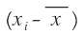  (mm) | 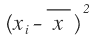  (mm)
1.
2.
3.
4.
5.
6.
7.
8.
9.
10.
11.
12.
13.
14.
15.
16.
17.
18.
19.
20.
21.
22.
23.
24.
25.
26.
27.
28.
29.
30.
31.
32.
33.
34.
35.
36.
37.
38.
39.
40.
41.
42.
43.
44.
45.
46.
47.
48.
49.
50.
 | Mean = |  | 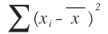=
 |  | Variance (s²) | 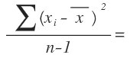
 |  | Standard Dev (s)

DATA QUESTIONS (to help you with making and presenting your graph):
1. Which size category had the most number of beans?___DEPENDS ON DATA___
2. Which size category had the least number of beans?___DEPENDS ON DATA____
3. What is the mean (average) length of the beans? ___DEPENDS ON DATA________

Table 2. Bean size summary (SUMMARY/POPULATION TOTALS) THESE ARE IDEALIZED DATA
Size Category in millimeters (begin with the smallest bean category) | Total number of beans (use tally marks)
Example 9 mm | || (if 2 beans measured 9 mm)
9 mm | I (1)
10 mm | III (3)
11 mm | IIIII (5)
12 mm | IIIIIII (7)
13 mm | IIIIIIIIIIIII (9)
14 mm | IIIIIIIIIIIII (9)
15 mm | IIIIIII (7)
16 mm | IIIII (5)
17 mm | III (3)
18 mm | I (1)
19 mm
20 mm
Once you have placed all the tally marks, turn your paper sideways. What shape does your data make?
ANALYSIS QUESTIONS
Expected answers from students (italicized)
1. How could the size of each bean reflect the interaction between the environment and the genetics of the bean? (What determines the size of each bean? Think about the plants where the beans come from.)
The size of each individual bean is the result of the interaction between the genes (genetic information, DNA) and the environment (light amount, water, soil conditions, etc.)
Genes present the required information for biological organisms to develop and exist, but the environment will dictate the extent to which these genes are expressed. For example, a plant with “tall” genes may not grow to be “tall” if the environment is not conducive for this growth. Poor soil conditions, limited water access, and/or sunlight will impact the height of the plant (even if the genes for “tall” are present).
2. Why even under ideal environmental conditions can the beans not change their size? (Given ideal environmental conditions, can individual beans change their size?)
No, individuals cannot change their size. Size of beans is dictated by the genes and the environment. For example, a bean that does not have the genes for being “long” cannot become long - it would need to have those genes to begin with.
In some ways, this question is asking students to consider the idea that individuals have a “desire to evolve”. But evolution is not about “trying, wanting, or desiring”.
“Natural selection leads to the adaptation of species over time, but the process does not involve effort, trying, or wanting. Natural selection naturally results from genetic variation in a population and the fact that some of those variants may be able to leave more offspring in the next generation than other variants. That genetic variation is generated by random mutation — a process that is unaffected by what organisms in the population want or what they are "trying" to do. Either an individual has genes that are good enough to survive and reproduce, or it does not; it can't get the right genes by "trying." For example, bacteria do not evolve resistance to our antibiotics because they "try" so hard. Instead, resistance evolves because random mutation happens to generate some individuals that are better able to survive the antibiotic, and these individuals can reproduce more than others, leaving behind more resistant bacteria.” from https://evolution.berkeley.edu/evolibrary/misconceptions_faq.php
3. An example of “natural selection” may be a drought when smaller beans die faster than larger beans (which have greater water reserves). What effect would this selection have on the next generation (population) of beans?
Since the larger beans are more likely to survive the drought conditions, then the smaller beans would be “naturally” removed from the breeding population. Therefore, the future generation of beans would be comprised of larger beans compared to the original population.

4. If a group of early humans (hunter/gatherers that did not cultivate beans) preferred smaller beans over larger beans, what would happen to the future population of beans?
If humans preferred smaller beans (removed these from the breeding population), the proportion of small beans will be reduced and the proportion of larger beans would increase. Under these conditions “natural selection” was happening because of human activity- but in a natural way (without selective breeding).

5. In modern agricultural societies, we cultivate plants that offer us desired characteristics. This process of “artificial selection” is often seen in mono-cultured crops. What is the long term effect of selecting for specific traits?
Humans will select for characteristics that are valued and breed (reproduce) for these traits. For example, currently Cavendish bananas are by far the main commercial banana cultivars sold in the world market, but there are many varieties of bananas around the world.
from: https://evolution.berkeley.edu/evolibrary/misconceptions_faq.php#a6
We are also responsible for decreasing the genetic pool which also puts species at risk of extinction since pathogens that kill one organism, can also kill the whole population. This is currently the case with bananas which are threatened by a fungus (https://www.bbc.com/news/uk-england-35131751) and arabica coffee (https://www.sciencealert.com/the-majority-of-wild-coffee-species-could-be-headed-for-extinction).

6. The process of choosing certain characteristics is called selection. Selection can be “natural” (naturally occurring processes) or “artificial” (caused directly by human intervention). Using the beans in question 3, 4 or 5, explain why the bean population would change in size after 10 years. *(HINT: would the large beans be able to reproduce after they are eaten?) How would the graph compare to the original graph you made?
The bean population would change in size because the beans that had the genes for being smaller/larger would no longer be part of the population. Three conditions must be met for selection to take place:
1. There must be variation within the population of organisms., 2. That variation must be heritable. and 3. There must be differences in reproductive success based on those heritable differences. https://ncse.com/creationism/analysis/artificial-vs-natural-selection. Therefore, reducing the genetic pool (removing beans with a specific characteristic) would reduce/remove variations from the population and create “directional selection” (http://www.oxfordbibliographies.com/view/document/obo-9780199941728/obo-9780199941728-00490.xml). A classic example of this is the peppered moths in England (https://askabiologist.asu.edu/peppered-moth)
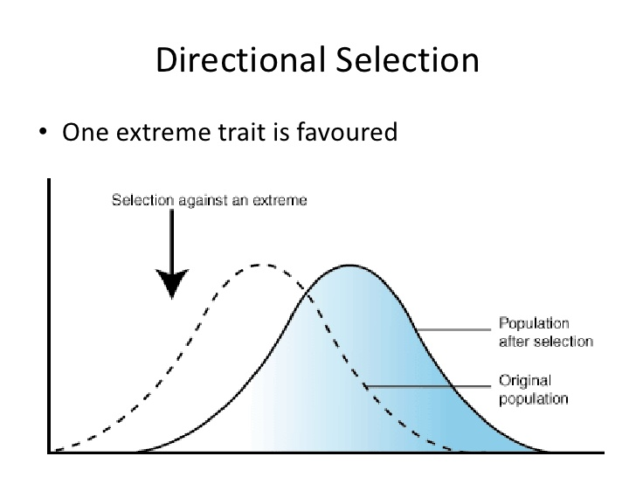
7. What does the standard deviation tell you about your data? (optional)
When data is gathered, Standard deviation is a statistic (a number) that tells you how tightly all the various examples are clustered around the mean in a set of data. This number is used to tell how measurements for a group are spread out from the average (mean), or expected value. A low standard deviation means that most of the numbers are very close to the average. A high standard deviation means that the numbers are spread out. In many instances when we gather data where the data tends to be around a central value with no bias left or right, and it gets close to a "Normal Distribution" (this is the case with the beans). The "Bell Curve" is a Normal Distribution and many things closely follow a Normal Distribution such as lengths of beans, heights of people, the mass of animals, errors in measurements, blood pressure, etc. When graphed, normal distributions look like this: 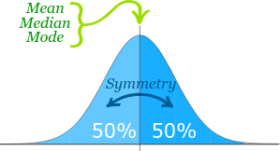
Moreover, the “width” of the curve is the “standard deviation”. So measurements that are really close to the mean will small standard deviation; while measurements that are far from the mean will have large standard deviations.
