补充素材：
Migration: 1. Show some pictures of spiral to students and ask the students about the relationship between e and these spirals.

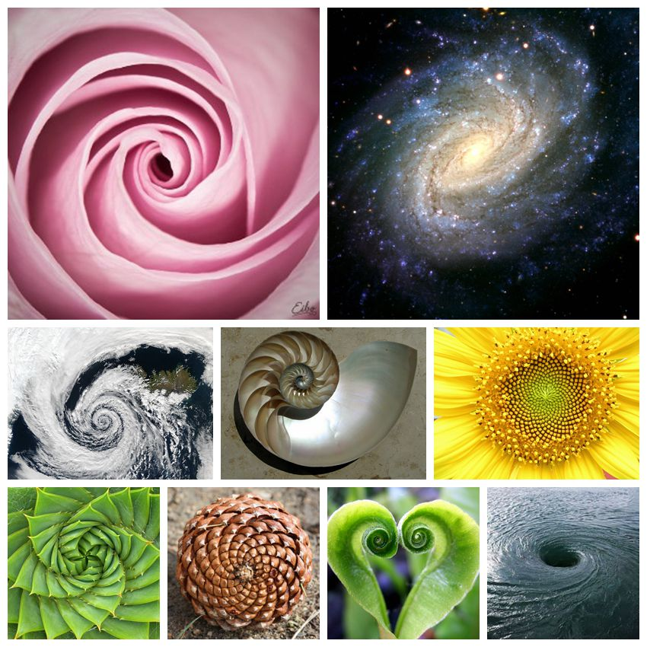
提问：请同学们查阅资料，并说明螺线与e有何关系。

2.Show two logarithmic tables (one takes 10 as base and the other takes (1.0001=（1+r）) as base. So students will see that the numbers in the table with the base of (1.0001=（1+r）) has smaller intervals so it is more useful.

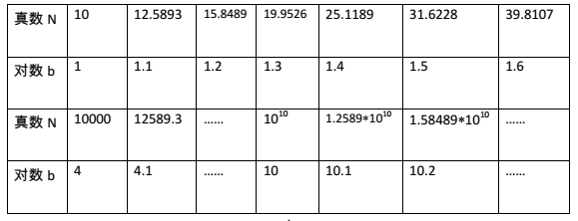
the logarithmic table with base 10 numbers
(真数N: real number N, 对数b：logarithm b)

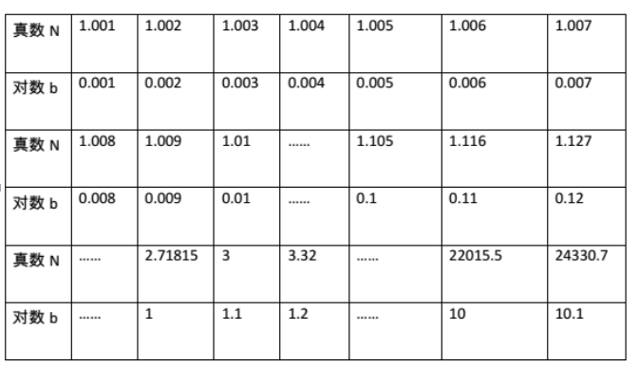

the logarithmic table with (1.001=（1+r）)numbers
(真数N: real number N, 对数b：logarithm b)

