TEACHER’s GUIDE

ATP: The Fuel of Life by Christian R. Schubert, Ph.D.

Scope of the Lesson

The goal of this lesson is to introduce students who are interested in human biology and biochemistry to the subtleties of energy metabolism (typically not presented in standard biology and biochemistry textbooks) through the lens of ATP as the primary energy currency of the cell. Avoiding the details of the major pathways of energy production (such as glycolysis, the citric acid cycle, and oxidative phosphorylation), this lesson is focused exclusively on ATP, which is truly the fuel of life. Starting with the discovery and history of ATP, this lesson will walk the students through 8 segments (outlined below) interspersed by 7 in-class challenge questions and activities, to the final step of ATP production by the ATP synthase, an amazing molecular machine.

Prerequisites

A basic understanding of the components and subcellular organization (e.g. organelles, membranes, etc.) and chemical foundation (e.g. biomolecules, chemical equilibrium, biochemical energetics, etc.) of a eukaryotic cell is a desired prerequisite, but it is not a must. This lesson is designed to spark the students’ interest in biochemistry and human biology as a whole, but could serve as an introductory lesson to teaching advanced concepts of metabolism and bioenergetics in high school depending on the local science curriculum.

SEGMENT 1 Objectives

- Challenge the students to think about why food is generally important to humans, and why we need to eat so regularly compared to many other species (i.e. hibernating animals). What’s the purpose of eating?

The goal of the first segment is to introduce the BLOSSOMS speaker and challenge the students to think about why food is generally important to humans. One can pose the question of why we need to eat so regularly compared to other animals, e.g. hibernating bears. Or more generally, what is the purpose of us humans having to eat? The segment will end with the first in-class activity that challenges the students to come up with a list of biomolecules we eat every day.

ACTIVITY 1 Objectives

- Give students 1-2 minutes to think about the answer and discuss it with their peers in groups of 2-4 students, then take a class poll and note the answers on the board.
- If no answers are provided to the students upfront, students’ responses should be recorded in orders of magnitude (e.g. single digit integers, double digit integers, triple digit integers, etc.).

The in-class teacher should (1) project a slide displaying the question and its selected answer choices, or (2) write the question and answers on a black/whiteboard, or (3) prepare a handout for the students that has the question and answer choices written on it, or (4) simply pose the question, omitting the answer choices and opening the question up for a free discussion. After giving the students 1-2 minutes to think about the answer and discuss it with their peers in groups of 2-4 students, the teacher should take a poll, either by show of hands or by selecting a representative speaker for each student group, and note the answers on the board. If (4) is chosen (i.e. not provide answer choices in advance), the teacher should note the answers in orders of magnitude (e.g. single digit integers, double digit integers, triple digit integers, etc.). The answer will follow in Segment 2.

How many molecules are central to converting the nutrients we gain from eating our food and in our cells transforming them into a form of energy our bodies can use readily?

- 1
- 10
- 100
- 1000

Answer: 1 = ATP, the currency of life

SEGMENT 2 Objectives

- Answer challenge question to Activity 1.
- Give an overview of the discovery and history of ATP: its chemical name, structure, and some facts regarding its discovery.

This segment will answer challenge question to Activity 1. It will be followed by an overview of the discovery and history of ATP: its chemical name, structure, and some facts regarding its discovery. The function of ATP will be discussed in later segments. We’ll finish the segment with a challenge question asking how it can be that one molecule can be so central to life. What are the physical principles behind it? This will lead the students to think about the different types of biomacromolecules and how they can be transformed into each other when humans are actively using energy in the following in-class Activity 2.

ACTIVITY 2 Objectives

- Set the context and instruct the students to think about food in a biochemical meaning, not broad food groups.
- Identify the four main biomacromolecule classes: carbohydrates, protein, lipids, and nucleic acids.

This in-class segment will challenge the class to briefly discuss two questions embedded in the lesson video. The teacher should set the context and instruct the students to think about food in an organic and biochemical meaning, instead of simply listing the broadly defined food groups such as grains, fruits, vegetables, meats, dairy, nuts and seeds, etc. The teacher could bring certain foods into the classroom: e.g. bread or a bagel (carbohydrates), milk or meat (protein), cheese (lipids), fruit and vegetables (vitamins and minerals). Alternatively, the teacher could ask the students to think about what’s on the students’ lunch plate when they go to eat each day at school – they should arrive at the same broad categories. The goal is to get the class involved in a brief, interactive brainstorming session to come up with keyword ideas to answer these questions. The teacher should categorize the students’ answers and write them on the board. For example, if a student mentions “meat”, the teacher should write that down, and ultimately categorize it as “protein”. Similarly, if a student mentions “fruit”, the teacher should categorize that as “carbohydrate” and “vitamins and minerals”, and so forth. The most important point is that at the end of the activity, the four main biomacromolecule classes which provide our body with the necessary energy to maintain life, are up on the board: carbohydrates, protein, lipids, and nucleic acids.

(a) What is in the food we eat that makes eating such a necessary habit?

Answer:
Carbohydrates, protein, lipids, and nucleic acids. In addition, vitamins and minerals.

(b) What is the purpose of the various biomacromolecules in our body?

Answer:
They’ll get broken down to provide our cells with the necessary energy to keep us alive.

SEGMENT 3 Objectives

- Answer challenge question to Activity 2.
- Introduce the broad metabolic pathways in which the foods we ingest are transformed into the energy we need for an active life.
- Show that all metabolic pathways converge on the central production of one molecule that stores the energy converted from food digestion: ATP.

This segment will answer the challenge question to Activity 2, followed by an introduction of the broad metabolic pathways in which the foods we ingest are transformed into the energy we need for an active life. The main point of this segment is to show that independent of the input food source (protein, sugar, or fat), all metabolic pathways converge on the central production of one molecule: ATP. The segment will finish with a challenge question asking the students to think about what makes ATP a special molecule energetically.

ACTIVITY 3 Objectives

- The goal of this exercise is to get the students thinking about the components that make up the ATP molecule, how they are connected, and what could make this molecule such a preferred choice of metabolic output.
- In addition, the teacher could ask the class what class of organic macromolecules is composed of monomers similar to ATP? Answer: Nucleotides that make up RNA and DNA: ATP, GTP (purine bases) and CTP, UTP/TTP (pyrimidine bases).

The structure of ATP is embedded in the lesson video. Alternatively, the teacher could project it on a screen, draw it on the board, or provide handouts with the structure of the molecule on it. The goal of this exercise is to get the students thinking about the components that make up the ATP molecule, how they are connected, and what could make this molecule such a preferred choice of metabolic output. In-class, the students should describe the components and organization and note what they see: 3 phosphates connected by two phosphoanhydride bonds, 1 ribose (5-carbon sugar) connected to the 5’ phosphate by a phosphodiester bond, 1 adenine base connected at the C1 ribose carbon. In addition, the teacher could ask the class what class of organic macromolecules is composed of monomers similar to ATP? Answer: Nucleotides that make up RNA and DNA: ATP, GTP (purine bases) and CTP, UTP/TTP (pyrimidine bases).

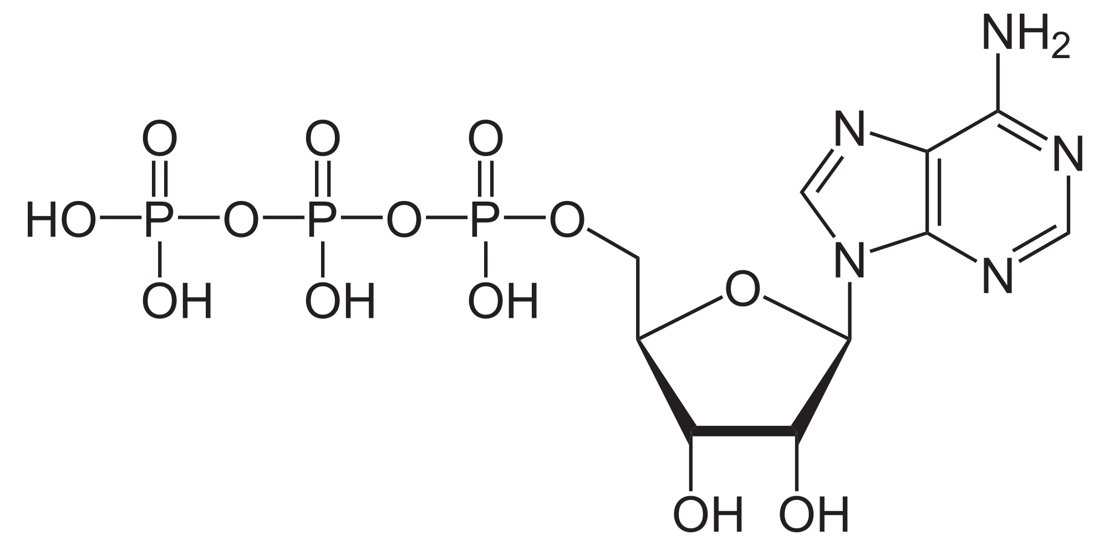

The following animation about ATP structure is embedded in the lesson video:
http://www.youtube.com/watch?v=ASe_cKcuzKc

SEGMENT 4 Objectives

- Answer challenge question to Activity 3.
- Introduce what it is that makes ATP such a special molecule that fuels our cells.
- Explain the nature of the phosphoanhydride bond and its role as an energy carrier.

This segment will answer challenge question to Activity 3. It will then introduce what it is that makes ATP such a special molecule that fuels our cells, and well as go into an explanation of the nature of the phosphoanhydride bond and its role as an energy carrier. Optional: Compare and contrast to other cellular molecules with a similar role.

ACTIVITY 4 Objectives

- After giving the students 1-2 minutes to think about the answer and discuss it with their peers in groups of 2-4 students, the teacher should take a class poll and note the answers on the board.
- If no answers are provided in advance, the teacher should note the answers in orders of magnitude. Details of the calculation are presented in Segment 5.

The in-class question is embedded in the lesson video. After giving the students 1-2 minutes to think about the answer and discuss it with their peers in groups of 2-4 students, the teacher should take a poll, either by show of hands or by selecting a representative speaker for each student group, and note the answers on the board. If no answers are provided in advance, the teacher should note the answers in orders of magnitude. I will work through the details of the calculation in Segment 5. The teacher needs to set the stage for this exercise, and let the students know that metabolic processes that use ATP (e.g. running, walking, thinking, etc.) as an energy source convert it back into its precursors, ADP and inorganic phosphate (Pi), utilizing one water molecule through a process known as hydrolysis. Put the simple hydrolysis equation on the board/slide/handout, which is also embedded in the lesson video:

ATP + H2O → ADP + P_{i}

Assume an average human (70 kg body weight). How much ATP do you think this human hydrolyzes every day in his or her life? Give a brief justification to of why you chose your number!

- 5-10 g
- 50-100 g
- 1-2 kg
- 20-30 kg
- 60-70 kg

Answer:
70 kg. As an average human, we metabolize approximately our own body weight of ATP each day of our lives!

SEGMENT 5 Objectives

- Answer challenge question to Activity 4.
- Introduce the amazing power of our human body to recycle the equivalent of our own body weight in ATP each day of our lives.
- Lead up to Activity 5, a quick back-of-the-envelope calculation regarding the commercial value of our body as a factory for ATP synthesis.

In this segment, I will answer the challenge question to Activity 4, and introduce the amazing power of our human body to recycle the equivalent of our own body weight in ATP each day of our lives. I will go through this calculation in the segment, which leads up to Activity 5, a quick back-of-the-envelope calculation regarding the commercial value of our body as a factory for ATP synthesis.

ACTIVITY 5 Objectives

- This short in-class activity poses a simple question for open discussion, but it is not expected that the students arrive at an actual $$$ value.
- After a brief in-class discussion, I will walk the students through a back-of-the-envelope calculation of the commercial value of ATP production in our bodies that occurs every day of our lives.

If you had to put a price tag on our daily ATP production, how much do you think each of us would be worth?

Answer: $20/g/day x 70,000g = $1,400,000/day

To put a price tag on this ATP turnover, at current commercial prices of about $20 per gram, it would cost approximately $1,377,500 – more than 1 million dollars! – per day. In this context, the ability of our body to biochemically sustain its amazing activity is even more fascinating, and deserves our deepest respect. It is crucial to make this point clear to the students!

SEGMENT 6 Objectives

- Introduce the flow of metabolic substrates from glucose breakdown to ATP synthesis through glycolysis, citric acid cycle, and oxidative phosphorylation.
- Focus on oxidative phosphorylation, the final process, and emphasize that the details of metabolism are very complex, but well worth understanding in detail in advanced classes.

The goal of this segment is to introduce the students on a very generalized level to the flow of energy conversion from food to ATP through the major metabolic pathways in the cell. Using glucose as an example, I will walk the students through the general principles of glycolysis, the citric acid cycle, and oxidative phosphorylation.

ACTIVITY 6 Objectives

- Challenge the students to think about how many molecules of ATP can be made from one molecule of glucose.
- After giving the students 1-2 minutes to think about the answer and discuss it with their peers in groups of 2-4 students, the teacher should take a poll and note the answers on the board.

The in-class teacher should (1) project a slide displaying the question and its selected answer choices, or (2) write the question and answers on a black/whiteboard, or (3) prepare a handout for the students that has the question and answer choices written on it, or (4) simply pose the question, omitting the answer choices and opening the question up for a free discussion. After giving the students 1-2 minutes to think about the answer and discuss it with their peers in groups of 2-4 students, the teacher should take a poll, either by show of hands or by selecting a representative speaker for each student group, and note the answers on the board. If (4) is chosen (i.e. not provide answer choices in advance), the teacher should note the answers in orders of magnitude (e.g. single digit integers, double digit integers, triple digit integers, etc.). The answer will follow as we work through Segment 6.

How many molecules of ATP can be made from one molecule of glucose? Give a brief justification to of why you chose your number!

- 2
- 4
- 20
- 40
- 100

Answer: 40 = roughly 36-40 molecules of ATP can be made from one glucose molecule through glycolysis, the citric acid cycle, and oxidative phosphorylation; an amplification of about 40-fold!

SEGMENT 7 Objectives

- Answer challenge question to Activity 6.
- Introduce the concept of proton gradients generated during the electron transport chain that drives oxidative phosphorylation.
- Introduce the ATP Synthase as an amazing molecular machine!

This segment will take the students through the production pathway of ATP during oxidative phosphorylation, and end with an outlook of the ATP Synthase, an amazing example of molecular machinery at a nanoscale.

ACTIVITY 7 Objectives

- Watch in-class animation of ATPase at work integrated into the session video.
- This activity does not involve any work on the students’ part, but I expect the students to be wowed by the amazing workings of this wonderful machine.
- It is left up to the discretion of the teacher to discuss the workings of the ATP Synthase in greater detail depending on the level of the class, or refer to advanced courses in high school or college.

http://www.youtube.com/watch?v=PjdPTY1wHdQ

This in-class activity will be embedded in the lesson video, and contains a short video animation of the inner workings of the ATP Synthase. Depending on the background of the class and knowledge, the teacher could introduce an extended discussion here of molecular machines at a nanoscale, which work very much by the same physical principles as our large scale machinery we see every day, e.g. windmills and turbines.

SEGMENT 8 Objectives:

- Recap the wonder of the molecular machine presented in Activity 7.
- Summarize the concepts of cellular respiration based on the example of glucose oxidation.
- Introduce the wider realm of metabolism that helps us produce energy.

In this final segment, I will recap the major principles we learned in the lesson of how nutrients are extracted from our food and the energy stored in them is converted to the single energy currency of the cell, ATP, which can then be used to power our bodies day in and day out of our lives. The segment will end with a brief outlook to challenge the students to think about what happens to the food they ingest when they have their next meal, and highlight the importance of a balanced diet to maintain a healthy energy balance.

QUESTIONS – COMMENTS – CONCERNS?

If you have any questions, comments, and/or concerns, please don’t hesitate to get in touch. I hope you enjoyed or will enjoy the lesson!

blossoms.crs@gmail.com

