Arabesque ... Where Art Meets Mathematics
Teacher's Guide
General Objective:
The main objective of this lesson is to illustrate the visual side of the important applications of mathematics in practical life, the relationship of mathematics and decoration. Most of the pictures selected for this lesson are visible on the walls of the Al-Hambra - Granada (Andalusia), which is one of the most important landmarks in Islamic civilization.
Educational Goals:
1) establish the concept of isometrics
2) demonstrate the importance of matrices and their applications
3) give real life examples of groups
Previous Requirements:
As background for this lesson, students just need some familiarity with the concept of a group and a limited knowledge about matrices and the inverse of a non-singular matrix.
Classroom Activities
Activity One: the symmetries preserve the dimensions, it seems logical to first answer the following question: What are the group symmetries of the department?

Activity Two: Find all the analogies in the shammag displayed in front of you. Note: A shammag is a headscarf used by men in many Arab countries.

Activity Three: Draw a triangle Alodhaa identical, then the story and try to answer the following questions:
What group of symmetries is identical to equilateral triangle?
Is this group a subgroup of E?

Activity Four: Draw a number of regular polygons with 5 ribs and then try to cut and paste them side by side. What do you notice? Try the same operation with regular polygons while increasing the number of ribs to 6, and then try polygons with 7 ribs. What did you conclude? What are the regular polygons that can be stacked side by side to cover the wall without leaving any spaces, and without there being any overlap between them?

Activity Five: What do you think of trying to find a construction unit basis in the following figure taken in the Al-Hambra?

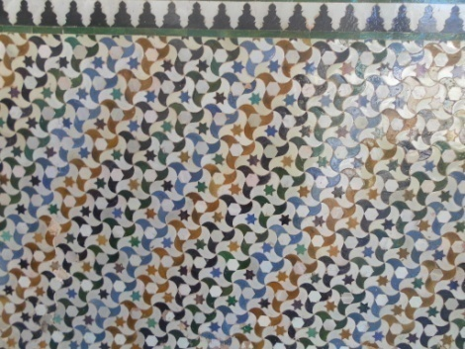

Activity Six: Class group paper on the wall as follows, which includes a copy of one of the famous paintings by the painter M.C. Escher (1898 – 1972), which was used in a lot of analogies to the well-known paintings.

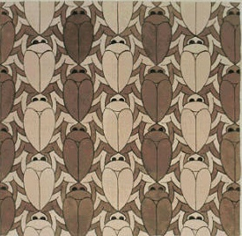

Note: For more exercises, you can use some of the examples shown on the following web page:

http://www.clowder.net/hop/17walppr/17walppr.html

