**Summary and Teacher’s Guide:**

**The Pythagorean Theorem, Geometry’s Most Elegant Theorem**

Sandra Haupt, mail.colonial.net/~shaupt

Hello, and welcome to this BLOSSOM learning module. I’ve been a teacher of mathematics at Concord-Carlisle High School in Massachusetts for the past 10 years. In previous incarnations I was a geophysicist in the petroleum industry in Colorado and worked in Environmental Law in Vermont. I have always been interested in the history of mathematical thinking and the development of mathematical concepts, and make a point to emphasize contributions from both Western and non-Western civilizations. This learning module teaches students about the history of the Pythagorean theorem, along with proofs and applications. Feel free to use your own motivational ideas and tailor it to your students!

This lesson is geared toward high school Geometry student that have completed a year of Algebra. The video portion is about thirty minutes, and with breaks could be completed in 50 minutes. (You may consider completing over two classes, particularly if you want to allow more time for activities or do some of the enrichment material). These activities could be done individually, in pairs, or groups, I think 2 or 3 students is optimal.

The materials required for the activities include scissors, tape, string and markers. Calculators are optional.

This lesson addresses the national standards of the National Council of Teachers of Mathematics and the Mid-continent Research for Education and Learning, specifically:

* Analyze characteristics and properties of two- and three-dimensional geometric shapes and develop mathematical arguments about geometric relationships
* Use visualization, spatial reasoning, and geometric modeling to solve problems
* Understand and apply basic and advanced properties of the concepts of geometry; Use the Pythagorean theorem and its converse and properties of special right triangles to solve mathematical and real-world problems;

-Although I don’t go through the origami proof, there is a link at the end of this guide.

-Are students familiar with the scarecrow’s statement from “The Wizard of Oz”? Can they find the errors? There are three mistakes!

-Students may be able to recite , but press them for details on what it means and how they might go about proving it.

Wooden puzzle-This is a 3,4,5 right triangle-and can be replicated on graph paper, students can color code, cut and rearrange to see how puzzle works.

“Proving” a theorem is different than knowing it or using it. The wooden puzzle was proving something specific to the 3, 4, 5 right triangle. The next proof is general.

Each student (or each pair) needs the puzzle worksheet, scissors and scotch tape.

It’s important to have students work on this (and even struggle for a bit) before giving any hints. The initial hint might be to combine pairs of triangles to form rectangles by matching so that the hypotenuse becomes the diagonal of the rectangle. It’s much harder to figure out how to combine those two rectangles with the remaining square! A subsequent hint is to combine the two rectangles to form an “L” shape. Students may be able to get the configuration right, but not know how to interpret it correctly. Another hint might be ‘where could you place the square relative to the two rectangles to have a square with side a and a square with side b? Once they figure out (or you show them) the correct position, it is helpful to draw a boundary delineating the two squares. It’s important that students share ideas, work cooperatively, and not give up too quickly! Once someone is successful, it is helpful for students to again have time to discuss, since not everyone will process this at the same rate.

Student should have sufficient algebra to FOIL or multiply two binomials. After combining like terms, students should calculate that the area of the outer square with sides a+b is . There are 4 red triangles with sides a and b. Each has an area of  for a total area of . Area of the inner yellow square with side c is . Since the area of the outer square equals the sum of the area of red triangles plus area of yellow square . Subtracting 2ab from each side gives us the Pythagorean theorem 

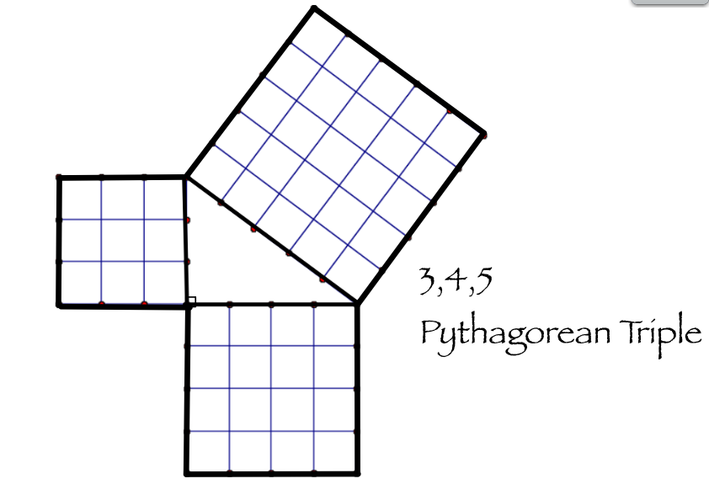Students do the algebra to calculate that legs 3 and 4 have a hypotenuse of 5.

This can be can also be cut and rearranged like the wooden puzzle. This leads directly to the next activity.

Give students a length of string, a marker and a scissors. See if they make a 3,4,5 right triangle by first marking off twelve even increments. It may be helpful to make a major mark on the string denoting 3 increments, 7 increments and 12 increments denoting the “bends” or vertices. Optional-if two students used the same increment, they could combine their right triangles to form a square.

Worksheet: Students should be able to use the Pythagorean theorem to solve for missing hypotenuse, or to rearrange the formula to solve for a missing side. Emphasize the importance of pattern recognition. Hopefully students will recognize that some triples are related by a scale factor.

The second part of the worksheet has irrational numbers. If the directions say to give an exact value, the answer for an irrational number must be in the form of a square root. A decimal approximation is not an acceptable form. Irrational numbers are a sophisticated concept. Ask students to discuss what does it mean to have a length that is an irrational number.

For enrichment, - a recipe for generating Pythagorean triples. Have students choose any two whole numbers “n” and “m”. This formula, published in Euclid’s Elements, will generate a Pythagorean triple. You could also ask students to prove Euclid’s formula algebraically.



Additional Activities:

Construction - Wheel of Theodorus: This construction can be done with a straight edge and compass, or with software programs such as Geogebra or Geometer’s Sketchpad.

Construct an isosceles right triangle with legs of length 1 unit. Calculate the hypotenuse of . Now construct a second right triangle adjacent to the first such that the hypotenuse of  is now a leg. The other leg is 1 unit. Calculate the hypotenuse of the second triangle to be . Construct a third right triangle adjacent to the second such that the hypotenuse of  is now a leg. The other leg is 1 unit. The hypotenuse of the second triangle will be or simply  Students can continue-they will recognize mathematical patterns as well as patterns in nature!

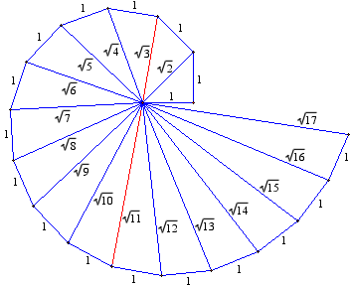

In the field “Treasure Hunt”: Students can do the 3,4,5 string (or rope) activity outside. Students could find the exact location a certain distance from a mark on a building. Merely having a tape measure and measuring is not sufficiently accurate since distance from a point to a line (wall) must be measured perpendicular to that wall. Students can construct a right angle using a 3,4,5 right triangle, then measure the distance along the leg.

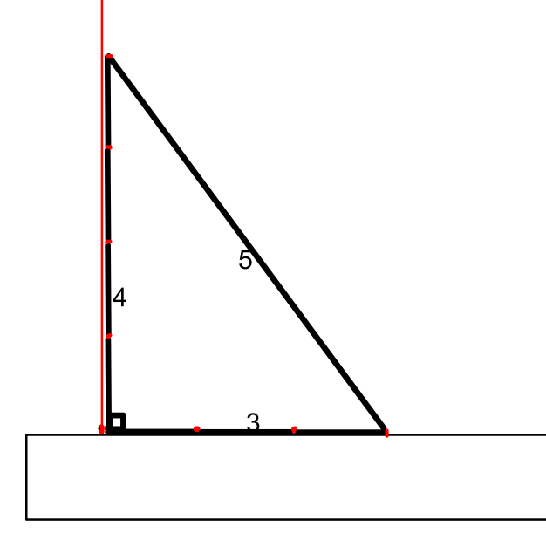

Thank you for choosing to share this video on the Pythagorean theorem with your students! If you have any questions, please feel free to contact me at [shaupt@colonial.net](mailto:shaupt@colonial.net)