Lesson: The Science Behind Music
Authors: Ing. Jazzmin Novelo y Rafael Eduardo Quero Osorio.

Introduction
In this lesson, students will get to know the concepts of physics and mathematics that are linked to music. Moreover, they will have the opportunity to engage in experiments that will allow them to test these concepts.

Learning Goals
The goal of this lesson is to understand the components of music and their relationship to basic Physics and Mathematics elements.

Requirements
None.

Length of the lesson
Thirty minutes, not including the time outside the class needed to assemble the monochord.

Materials
Building the monochord:
- A wooden board of about 70 cm long (A centered distance of 50 cm is required for the main body of the monochord). The segments at the ends are there to work with the elements needed to tense the chord.
- A guitar chord of about 60 cm long
- Two eyebolts, open or closed. Below are some images of eyebolts.

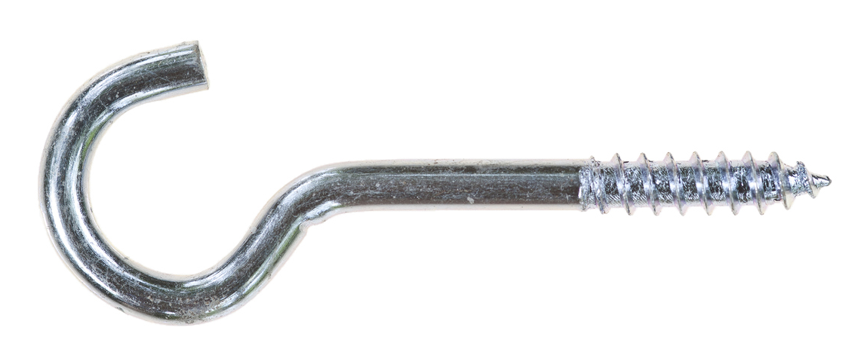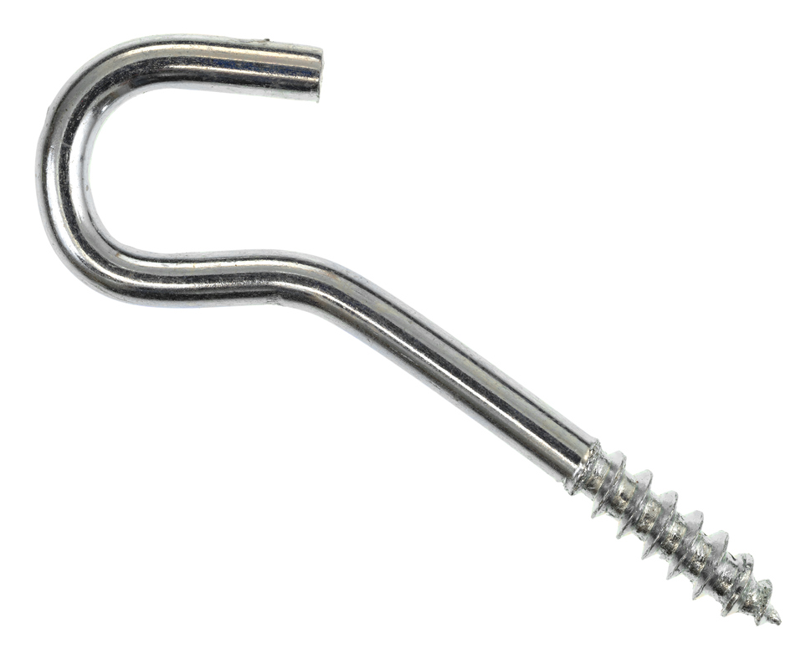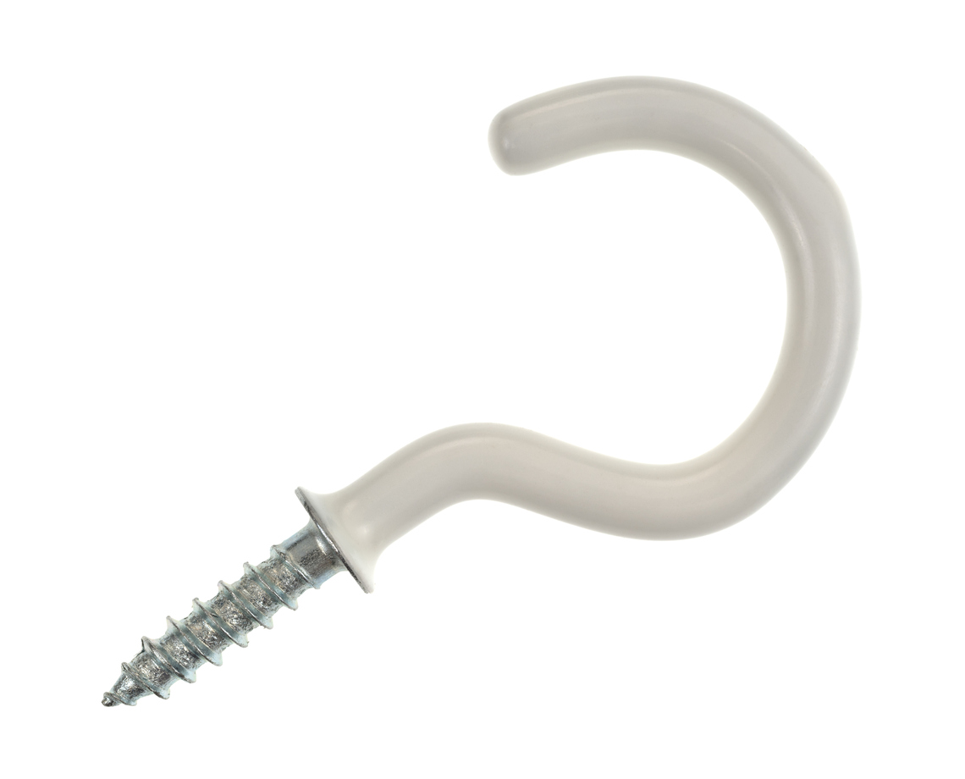

- Three wooden triangles (wedges) with a height of 1 cm. Each triangle should have a little notch to place the guitar chord.
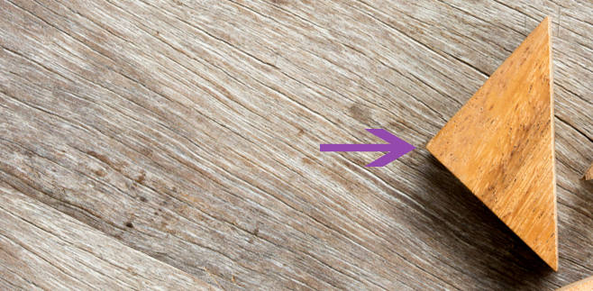
Here is the small notch

- A hammer.
- A razor blade.
- A strip of paper of 50 cm with the marks of the following distances: 8/9, 4/5, 3/4, 2/3, 16/27, 128/243.

Activity 1
- Previously assembled monochord
- A strip of paper of 50 cm, with the distances, in equivalent proportions: 8/9, 4/5, 3/4, 2/3, 16/27, 128/243.

Activity 2
- Two glass goblets.
- Water.
- Powdered dish detergent.

Activity 3
- The monochord
- An elastic chord in a different thickness than the monochord’s. For instance, a guitar, a violin, or a ukulele chord.

Activity 4
- Seven cylindrical bottles, with straight lines and no reliefs. Wine bottles, seltzer bottles, water bottles, and salsa bottles are recommended.
- Any of the following: a tuner; a musical instrument like a guitar, violin, or ukulele.
- Drumsticks, chopsticks, or a long metal nail.
- A jar of water.
- A funnel to fill the water bottles.
- Optional: Different colored dyes.

Development of the lesson
The lesson is made up of four segments and four activities, designed to guide the lesson. It iwll be necessary to consider the following:

Prior to Activity 1. Assembling the monochord

Start by nailing one eyebolt on one side of the wooden board. The distance between both eyebolts should be more than 70 cm Put the eyebolt on the other side.

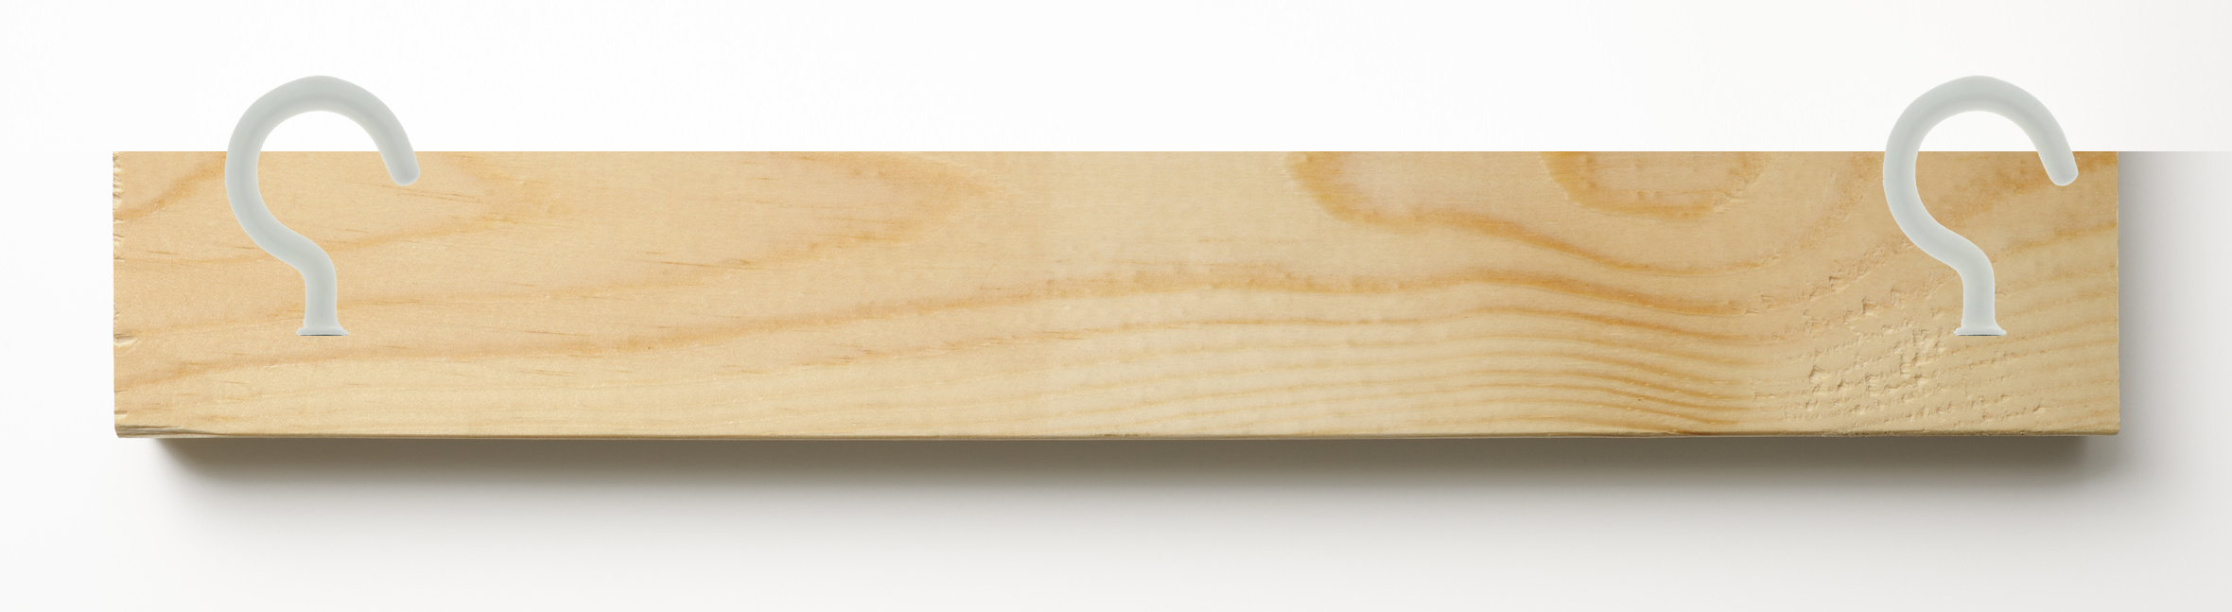
Distance of 70 cm

Next, tie the elastic string or cord on the ends of the wooden board. It should be very taut.

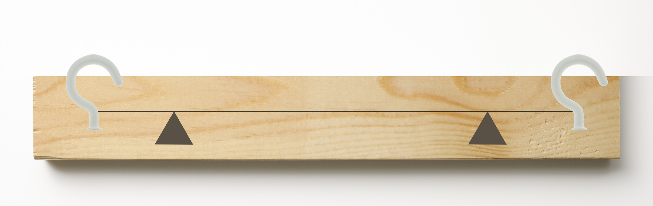
Distance of 50 cm

ACTIVITY 1
Triggering questions - Activity 1
Trigger questions are explained throughout the lesson. However, they can begin with a brief explanation about the relevance of music in their lives. For instance:

Music is a representation of ordered sounds. When grouped, they generate an informative and harmonious message and, when interacting with the air, they propagate. But- can this be demonstrated? And, how would you do it?

Activity 1

In Activity 1, the monochord should be used to prove the generation of musical notes. There are three elements in the monochord that can help us understand its functioning:

- The strip of paper, with the marks at 8/9, 4/5, 3/4, 2/3, 16/27, 128/243, 1/2 (these are the proportions of the length of the guitar chord that are vibrated to get the notes).

Proportion | Distance (From left to right, in cm) | Note
1/1 | 50.00 | DO (first octave)
8/9 | 44.44 | RE
4/5 | 40.00 | MI
3/4 | 37.50 | FA
2/3 | 33.33 | SOL
16/27 | 29.63 | LA
128/243 | 26.34 | SI
1/2 | 25.00 | DO (2nd octave)

- The guitar chord, which should be plucked to make it vibrate.
- The wooden wedges.

The fixed wedges work to raise the chord slightly above the wooden base, and also to define the efective length of the chord (50 cm), which will be divided in the given proportions. The third wedge slides on the board and can be placed on the selected mark.

The monochord is placed on a table and the marks on the strip of paper should be seen ( 8/9, 4/5, etc.). Start at the left of the observer.

First, to get the first musical note, DO (of the first octave), the chord is plucked at the middle (at a distance of 50cms, between the fixed wedges).

Next, to get the note RE, slide the wedge to the 8/9 mark. With one finger,
press the chord on the notch of the wedge. Pluck the proportion of the chord from left to the middle, to make it vibrate. Repeat this on marks 4/5 (MI), ¾ (FA), 2/3 (SOL), 16/27 (LA), 128/243 (SI) y ½ (DO of the next octave).

ACTIVIDAD 2. Experiment on waves and sound

Triggering questions – Activity 2
Consider the following questions for reflection during the activity: Are all mechanical waves sound? What is the difference between noise and musical sound? Do musical notes represent pure sound?
Activity 2
This experiment was selected because waves of water are a phenomenon that can be observed. For example, when a drop of water is dropped on more water, or the effects of the sound waves that can be directly heard by the ear, such as clapping. In addition, the body can detect some waves from the electromagnetic spectrum, like a radar (electromagnetic impulse).

It is important to mention that the teacher will not provide the glass cups for students. However, he/she can form groups so that there is a variety of glasses. Moreover, the teacher will need to bring his/her own glass cups to do a demonstration in class.

ACTIVITY 3. Timbre
Triggering questions - Activity 3
Students can think of the following while doing this activity: What differences do you see between the notes of the first, second, and third chord?

Activity 3
The chord of the monochord should be changed for one that is brought to class. If possible, you can record the sound that is emitted by the chord.

It is important that all chords are played on the same place. For instance, at the distance 4/5 or 8/9. The purpose of this is to show that the same note can have a different timbre, depending on the medium.

ACTIVITY 4. Constructing a xylophone with glass bottles

Triggering questions - Activity 4
Sound is the propagation of mechanical waves through a medium. We have a diapason, for example, and when it vibrate it transmits its vibrations through the air into the open space, until it reaches our ears. But the source of the sound is the diapason. Now respond:

- We have an empty glass bottle, which we make vibrate with a metallic object and we listen to its sound. Which vibration do we hear? The one from the air in its interior, the one of the glass bottle, or the one of the water? Explain your answer.
- Next, we pour water in the same bottle until a certain level. We tap the bottle with the metallic object. Which vibration de we hear? The one from the air in its interior, the one of the glass bottle, or the one of the water? Explain your answer.

- If we tap the bottle, filled with water at different levels- why do we hear different sounds? Explain your answer.

Activity 4
I recommend to look for the bottles and tune them at home, before class, so that when you arrive this part is done quickly.

To make the xylophone, you need to look for the right bottles. Get many bottles of different sizes, making sur ethat a good portion of the body of the bottle is cylindrical and flat. Because of this, you can gather the students in two teams and make two xylophones. This way, you will have more bottles to work with, and you will not have to tune that many bottles.

The bottles that work best are wine bottles, seltzer bottles, and salsa bottles. It is best to use transparent bottles because it is easy to see the amount of water they have inside.

Sometimes, it is hard to find bottles that produce low tones like C5, which is why we recommend tuning the xylophone to the Re major scale. Before starting the activity, think about the notes you want to get. For example, it could be a major scale, a pentatonic scale, or a chromatic scale.

Bottles with curves, shapes or short size, such as soda bottles, will not work. Remember they have to be flat and tall. We recommend the following type of bottle.

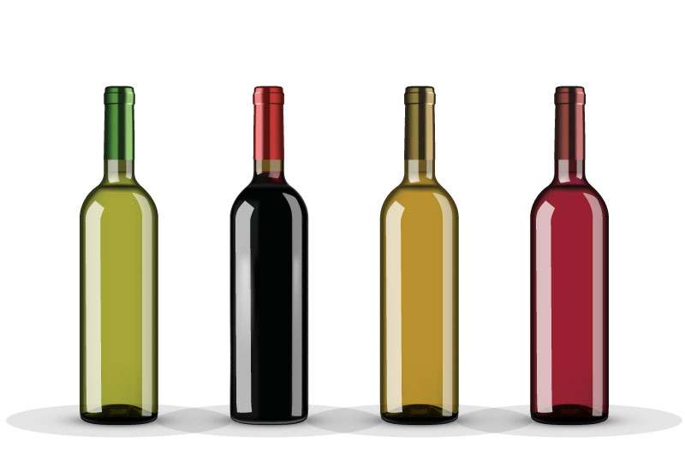

As in Segment 2, bottles need to be washed, clean, without grease or dust. To remove labels, I suggest you soak the bottle in hot water for a while.

When tuning the bottles, fill them up with water little by little. Tune them with as much precision as possible. You can download an app for tuning musical instrument on your phone, use a musical instrument, search for a webpage, or use a tuner.

When the bottles are tuned, add color in the water to classify them according to the musical notes. Use the color you want, it is only to distinguish the notes.

With the drumsticks, you can start to enjoy your xylophone. If you don’t have a drumstick, you can use a metal nail or chopsticks. For student safety, I recommend using chopsticks, because the nail is sharp and it can be dangerous in a large group.

You can play with your students the following melody: Twinkle, Twinkle Little Star, or any other melody you prefer. I recommend simple pieces, such as songs for children.

Twinkle Twinkle Little Star

CCGGAAG FFEEDDC CCGGAAG FFEEDDC
GGFFEED GGFFEED CCGGAAG FFEEDDC

